

VIETNAM NATIONAL UNIVERSITY - HO CHI MINH CITY

UNIVERSITY OF INFORMATION TECHNOLOGY

FACULTY OF INFORMATION SYSTEMS

Instructors: PhD. Cao Thị Nhạn, MS. Dương Phi Long

Group members: 

20522153

Phạm Quang Việt

19520935

Nguyễn Minh Thái

Phùng Trần Đăng Khôi

20520150

Từ Thị Huệ

21522109

CAPSTONE PROJECT FINAL REPORT

INFORMATION SYSTEM ANALYSIS AND DESIGN

COFFEE SHOP MANAGEMENT SYSTEM

HO CHI MINH CITY, 2023

**TABLE OF CONTENT**

*Chapter 1: INTRODUCTION* 1

1.1. Introduction 1

1.1. Research problems / Problems of the project 2

1.2. Research Objectives / Objectives of the project 2

1.3. Scope of project / Limitations of the study 3

1.4. Developer Tools & Technology 3

Chapter 2: *REQUIREMENT SPECIFICATION* 4

2.1. Situation survey/ Survey of the current situation 4

2.1.1. Interview 4

2.1.2. Survey of the organization/ Current organizational situation 9

2.1.3. Survey of business processes, major activities 9

2.2. Software requirements 11

2.2.1. Functional requirements 11

2.2.2. Non-functional requirements 12

Chapter 3: *ANALYSIS AND DESIGN* 14

3.1. Use-case Diagram 14

3.1.1. List of actors 15

3.1.2. List of Use-case 15

3.2. Use-case specification and activity diagram (Activity Diagram) 16

3.2.1. Log in: 16

3.2.2. Manage individual account: 18

3.2.3. Manage order: 20

3.2.4. Manage payment: 24

3.2.5. Arrange table: 26

3.2.6. Play the announcement speaker: 28

3.2.7. Manage account: 30

3.2.8. Manage surcharges: 32

3.2.9. Manage categories: 34

3.2.10. Manage table: 36

3.2.11. Manage discount codes: 39

3.2.12. Manage menu: 41

3.2.13. Revenue statistics: 43

3.2.14. Manage shop information: 45

3.3. Sequence Diagram and Class Diagram 47

3.3.1. Log in 47

3.3.1.1. Sequence diagram 47

3.3.1.2. Class Diagram 47

3.3.2. Manage individual account 48

3.3.2.1. Sequence diagram 48

3.3.2.2. Class Diagram 49

3.3.3. Manage order 50

3.3.3.1. Sequence diagram 50

3.3.3.2. Class Diagram 53

3.3.4. Manage payment: 55

3.3.4.1. Sequence diagram: 55

3.3.4.2. Class diagram: 56

3.3.5. Arrange table: 56

3.3.5.1. Sequence diagram 56

3.3.5.2. Class diagram: 59

3.3.6. Play the announcement speaker: 60

3.3.6.1. Sequence diagram: 60

3.3.6.2. Class diagram: 61

3.3.7. Manage account: 62

3.3.7.1. Sequence diagram: 62

3.3.7.2. Class diagram: 65

3.3.8. Manage surcharges: 66

3.3.8.1. Sequence diagram: 66

3.3.8.2. Class diagram: 69

3.3.9. Manage categories: 69

3.3.9.1. Sequence diagram: 69

3.3.9.2. Class diagram: 72

3.3.10. Manage table: 73

3.3.10.1. Sequence diagram: 73

3.3.10.2. Class diagram: 74

3.3.11. Manage discount codes: 74

3.3.11.1. Sequence diagram: 74

3.3.11.2. Class diagram: 76

3.3.12. Manage food and drink: 77

3.3.12.1. Sequence diagram: 77

3.3.12.2. Class diagram: 79

3.3.13. Revenue statistics: 80

3.3.13.1. Sequence diagram: 80

3.3.13.2. Class diagram: 81

3.3.14. Manage shop information: 82

3.3.14.1. Sequence diagram: 82

3.3.14.2. Class diagram: 83

3.4. Class Diagram and Entity class diagram: 84

3.4.1. Employee overview class diagram 84

3.4.2. Manager overview class diagram 85

3.4.3. Entity class diagram 86

3.4.4. Class diagram Specification 86

3.5. State diagram 101

3.5.1. Table 101

3.5.2. Discount code 101

3.5.3. Bill 102

3.6. Mapping to Relational Model from Entity class diagram: 103

*Chapter 4: IMPLEMENTATION AND TESTING* 104

4.1. Introduction to the implementation environment 104

4.2. User Interface 104

4.2.1. Employee Interface 104

4.2.2. Manager Interface 112

*Chapter 5: CONCLUSION* 118

5.1. Project achievement 118

5.2. Limitations 118

5.3. Development direction 119

*Chapter 6: SELF ASSESSMENT* 120

TABLE OF TABLES

Table 2.1: Survey Strategy 4

Table 2.2: Survey form 5

Table 2.3: Question & records 5

Table 3.1: List of actors 15

Table 3.2: List of use-case 15

Table 3.3: Log in - Use-case specification 16

Table 3.4: Manage individual account - Use-case specification 18

Table 3.5: Manage order - Use-case specification 20

Table 3.6: Manage payment - Use-case specification 24

Table 3.7: Arrange table - Use-case specification 26

Table 3.8: Play the announcement speaker - Use-case specification 28

Table 3.9: Manage account - Use-case specification 30

Table 3.10: Manage surcharges - Use-case specification 32

Table 3.11: Manage categories - Use-case specification 34

Table 3.12: Manage table - Use-case specification 36

Table 3.13: Manage discount codes - Use-case specification 39

Table 3.14: Manage menu - Use-case specification 41

Table 3.15: Manage statistics - Use-case specification 43

Table 3.16: Manage shop information - Use-case specification 45

Table 3.17: Account - Class diagram specification 86

Table 3.18: Bill - Class diagram specification 87

Table 3.19: BillInfo - Class diagram specification 88

Table 3.20: Discount - Class diagram specification 89

Table 3.21: DiscountCode - Class diagram specification 90

Table 3.22: Food - Class diagram specification 90

Table 3.23: FoodCategory - Class diagram specification 91

Table 3.24: Shop - Class diagram specification 92

Table 3.25: SurCharge - Class diagram specification 93

Table 3.26: TableFood - Class diagram specification 94

Table 3.27: Manage Account Controller - Class diagram specification 94

Table 3.28: Manage Bill Controller - Class diagram specification 95

Table 3.29: Manage BillInfo Controller - Class diagram specification 96

Table 3.30: Manage Discount Controller - Class diagram specification 97

Table 3.31: Manage DiscountCode Controller - Class diagram specification 97

Table 3.32: Manage food control - Class diagram specification 98

Table 3.33: Manage category control - Class diagram specification 98

Table 3.34: Manage shop control - Class diagram specification 99

Table 3.35: Manage surcharge control - Class diagram specification 99

Table 3.36: Manage table control - Class diagram specification 100

TABLE OF FIGURES

Figure 2.1: Current organizational 9

Figure 3.1: Use case diagram 14

Figure 3.2: Log in - Activity diagram 18

Figure 3.3: Manage individual account - Activity diagram 20

Figure 3.4: Manage order - Activity diagram 24

Figure 3.5: Manage payment - Activity diagram 26

Figure 3.6: Arrange table - Activity diagram 28

Figure 3.7: Play the announcement speaker - Activity diagram 30

Figure 3.12: Manage discount codes - Activity diagram 41

Figure 3.13: Manage menu - Activity diagram 43

Figure 3.14: Revenue statistics - Activity diagram 44

Figure 3.15: Manage shop information - Activity diagram 46

Figure 3.30: Arrange table - Class diagram 59

Figure 3.32: Play the announcement speaker - Class diagram 61

Figure 3.41: Choose day surcharges - Sequence diagram 68

Figure 3.51: Manage discount codes - Sequence diagram 74

Figure 3.52: Insert discount code - Sequence diagram 75

Figure 3.53: Update discount code - Sequence diagram 75

Figure 3.54: Delete discount code - Sequence diagram 76

Figure 3.55: Manage discount codes - Class diagram 76

Figure 3.56: Manage food and drink - Sequence diagram 77

Figure 3.57: Insert food - Sequence diagram 78

Figure 3.58: Update food - Sequence diagram 78

Figure 3.59: Delete food - Sequence diagram 79

Figure 3.60: Manage food and drink - Class diagram 79

Figure 3.61: Revenue statistics - Sequence diagram 80

Figure 3.62: Revenue statistics - Class diagram 81

Figure 3.63: Manage shop information - Sequence diagram 82

Figure 3.64: Set up shop information - Sequence diagram 82

Figure 3.65: Restore shop information - Sequence diagram 83

Figure 3.66: Manage shop information - Class diagram 83

Figure 3.67: Employee overview - Class diagram 84

Figure 3.68: Manager overview - Class diagram 85

Figure 3.69: Entity - Class diagram 86

Figure 3.70: Table - State diagram 101

Figure 3.71: Discount code - State diagram 101

Figure 4.1: Login page 104

Figure 4.2: Staff Home page 105

Figure 4.3: Information page 106

Figure 4.4: Order food 107

Figure 4.5: Combine table 108

Figure 4.6: Transfer table 109

Figure 4.7: Payment page 110

Figure 4.8: Invoice 111

Figure 4.9: Manager Home page 112

Figure 4.10: Manage Category Tab 112

Figure 4.11: Manage Food Tab 113

Figure 4.12: Manage Account Tab 113

Figure 4.13: Manage Table Tab 114

Figure 4.14: Manage Discount Code Tab 114

Figure 4.15: Manage Surcharge Tab 115

Figure 4.16: Statistic Tab 115

Figure 4.17: Manage Shop Information Tab 116

Figure 4.18: Run Notification Sound 116

Figure 4.19: Manage Notification Sound Locations 117

INTRODUCTION

## Introduction

In today's fast-paced world, coffee shops have become a popular hub for individuals to gather, relax, and fuel themselves with their favorite caffeine beverages. However, managing a coffee shop efficiently and effectively can be a challenging task. This is where a coffee shop management system comes into play.

A coffee shop management system is a comprehensive software solution designed to streamline and automate various aspects of running a coffee shop. It combines various tools and features that enable coffee shop owners to handle day-to-day operations seamlessly, enhance customer experiences, and drive business growth.

The primary goal of a coffee shop management system is to provide a centralized platform that integrates multiple functions, including point-of-sale, employee scheduling, reporting and analytics. By incorporating these functionalities into a unified system, coffee shop owners can optimize their operations, increase efficiency, and deliver an exceptional experience to their customers.

The point-of-sale component of a coffee shop management system serves as the backbone of the software. It allows staff members to efficiently process orders, handle payments, and generate receipts. By automating these tasks, the system minimizes human error, reduces waiting times, and ensures a smooth customer checkout process.

Finally, reporting and analytics capabilities are integral to a coffee shop management system. The system collects and analyzes data from various sources such as sales transactions. These insights provide valuable information to owners, enabling them to make data-driven decisions, identify trends, and identify areas for improvement.

In conclusion, a coffee shop management system revolutionizes the way coffee shops operate by providing an integrated platform to streamline operations, improve efficiency, and enhance the customer experience. By automating key processes, coffee shop owners can focus on delivering high-quality products and services, fostering customer loyalty, and driving business growth in the competitive coffee industry.

## Research problems / Problems of the project

Coffee shop owners strive to optimize their operations and improve efficiency. However, without a management system in place, manual processes and paperwork can lead to inefficiencies, errors in order processing, and difficulties in tracking sales and revenue. A management system can help streamline these operations and enhance overall efficiency.

Tracking sales and revenue is vital for coffee shop owners to assess the financial performance of their business. However, evaluating on manual processes and paper-based records can lead to inaccuracies and make it challenging to generate comprehensive sales reports and analyze revenue trends. A management system can automate sales tracking, generate real-time reports, and provide insights into revenue patterns.

Coffee shop owners often rely on external systems or services, such as payment processors, online ordering platforms, or accounting software. Integrating these external systems can seamlessly be a challenge without a dedicated management system. Implementing a management system with integration capabilities can streamline operations, improve data accuracy, and enhance the overall customer experience.

By addressing these problems through the implementation of a coffee shop management system, owners can streamline their operations, improve efficiency, enhance customer satisfaction, and make informed business decisions based on accurate and real-time data.

## Research Objectives / Objectives of the project

In the scope of this subject, we would like to create system management support coffee shop owners managing their shop.

There are some our systems main features:

* Manage food orders.
* Manage switch or merge tables.
* Manage information of foods, drinks, and tables.
* Manage order detail and payment.
* Account management.
* Output sheet for reports.
* Information is stored in a database, making it easy to retrieve, backup and restore easily, synchronous, fast, and reliable.

## Scope of project / Limitations of the study

Because of limitations about time, human, our teams focus to some main features such as:

* Menu management.
* Order foods/drinks management.
* Table management.
* Invoice detail.
* Notifications management.

## Developer Tools & Technology

* Git / GitHub for version control.
* Visual Studio Code as text editor.

REQUIREMENT SPECIFICATION

## Situation survey/ Survey of the current situation

### Interview

Table 2.1: Survey Strategy

|  |  |  |  |  |
| --- | --- | --- | --- | --- |
| **General survey**  System: Coffee Shop Management  Creator: Tu Thi Hue Create date: 20/04/2023 | | | | |
| Ord | Topic | Requirement | Start | End |
|  | Table management | Understand the process of managing the table to avoid overlapping tables and convenient management | 20/04/2023 | 20/04/2023 |
|  | Menu management | To get menu detail, categories of foods and drinks. | 20/04/2023 | 20/04/2023 |
|  | Order management | Understanding the process of ordering foods and drinks. | 20/04/2023 | 20/04/2023 |
|  | Reporting and Analytics | Process of making a report of revenue. | 20/04/2023 | 20/04/2023 |
|  | Integration with External Systems and devices. | Learn more about payment methods or order online and machinery resources, equipment. | 20/04/2023 | 20/04/2023 |

Table 2.2: Survey form

|  |  |
| --- | --- |
| **Survey form**  System: Coffee Shop Management | |
| Interviewee: Phung Tran Dang Khoi | Interviewer: Pham Quang Viet |
| Place: Coffee Shop | Start: 8:00 am 21/04/2023  End: 11:30 am 21/04/2023 |
| Target: Collect and understand working  process of specific Coffee Shop. |  |
| Details of the interview:   * Introduction * Overview of the current system * Survey plan: * Topic 1: Table management * Topic 2: Menu management * Topic 3: Order management * Topic 4: Reporting and Analytics * Topic 5: Integration with External Systems | Estimated Time:   * 5 minutes * 15 minutes * 30 minutes |
| General Observe |  |
| Unexpected occurrence |  |

Table 2.3: Question & records

|  |  |  |
| --- | --- | --- |
| Interviewee: Phung Tran Dang Khoi | 21/04/2023 | |
| Questions | Records | |
| Topic 1 | If the number of customers is too large and the number of tables is overloaded, how to handle it? | We will notify customers that there are enough tables available and customers are ready to wait for an empty table or want to change to another coffee shop. |
| How is table switching done? | We will check the tables to make sure the table customers want to move is empty and then make the move. |
| Topic 2 | How to deal with customers who order food or drinks, but the shop is out of stock? | We will apologize to the customer for the product you ordered and hope that you will order another item with some discount and we will announce for another customer to know this to avoid this case happening. |
| How are menu changes (e.g., adding or removing) made so that customers can know these changes? | We will print new menus and introduce them to customers through staff or banners and have promotional programs to reach customers. |
| Topic 3 | How does the shop manage customer orders? | We record the order on paper then the staff will send it down to the kitchen, the orders are put together a pin, the pre-orders will be pinned to the top, the kitchen will process the orders row from top to bottom. |
| Is there a case where the order is lost? | Yes, but we can't control the lost orders, when waiting too long customers will petition and order again (maybe) |
| Topic 4 | What statistics does the system need? | The system includes the following statistics:   * Statistics of all orders by day, month, year * Statistics of the shop's revenue over time identify. |
| Topic 5 | Do you use any external systems or services (e.g., payment processors, online ordering platforms) that you would like to integrate with the Management System? | Now we still accept cash payments, but we want to use online payment in our system. |
| What device do you currently use in shop management? (e.g., computer, printer) | We don’t use anything, We just use paper. With this system, we want to use with tablet and a printer to get invoices for our customers. |

### Survey of the organization/ Current organizational situation

Figure 2.1: Current organizational

### Survey of business processes, major activities

2.1.3.1. Owner

* **Menu management business:** Categorize the products in the menu into different groups to create order and easy search for customers, evaluate the price of each product in the menu based on the cost of ingredients, effort and desired profit.
* Importing information process:
* Input foods and drinks.
* Preprocess data and store in our database.
* Some kinds of data: foods/drinks information, price, discount.
* Pricing process:
* Based on the owner option price or customize.
* With specific formula.
* Store in database.
* **Revenue management business:** Revenue tracking and recording process, the owner needs to track and record the total daily, weekly, and monthly sales of the cafe.
* Revenue tracking and recording process:
* Collect information about sales, and payments.
* Calculate the total proceeds from the sale.
* Statistics of the amount from time to time and update to the database.
* **Staff management business:** An essential aspect of the coffee shop owner's business operations. It involves effectively managing the employees to ensure smooth and efficient operation of the coffee shop.
* Process of managing employee information:
* Recruitment.
* Enter employee information.
* Update employee information.

2.1.3.1 Staff

* **Order management business:** A crucial aspect of the staff's responsibilities in a coffee shop. It involves efficiently managing customer orders from the moment they are placed until they are fulfilled. Include order taking process, order processing, payment processing.
* Order taking process:
* Recording the order details such as items, quantities, and any specialrequirements.
* Order processing:
* Receive orders and enter information into the order management system
* Payment processing
* Get order slips, receipts, or invoices and save data in database.

## Software requirements

### Functional requirements

* Point-of-Sale Functionality: The system should have a user-friendly interface for processing customer orders, including options for adding items, customization, modifiers, and handling discounts or promotions. It should support different payment methods, generate receipts, and calculate change accurately.
* Menu Management: The system should allow coffee shop owners to create and manage their menu items, including beverages, food items, and combo deals. It should support categorization, pricing, ingredient management, and easy modification of menu items as needed.
* Sales Reporting and Analytics: The system should provide comprehensive reporting and analytics capabilities to monitor sales performance. It should generate reports on daily, weekly, and monthly sales, identify top-selling items, track revenue trends, and provide insights for data-driven decision making.
* Table and Order Management: If the coffee shop has a seating area, the system should support table management, allowing staff to assign tables to customers, track table occupancy, and manage orders per table. It should facilitate efficient table turnover and order tracking to ensure timely service.
* Reporting and Dashboard: The system should provide a centralized dashboard for coffee shop owners and managers to view key performance indicators, sales trends, inventory status, and other relevant metrics. Customizable reports should be available for various aspects of the business, such as sales, inventory, and employee performance.
* Integration with External Device: The system should have the capability to integrate with other devices, such as printer. This integration allows for a seamless flow of data and enhances operational efficiency.
* Security and Access Controls: The system should implement appropriate security measures to protect data such as financial records. It should have role-based access controls to ensure that only authorized personnel can access specific functions or sensitive data within the system.

### Non-functional requirements

* Performance: The system should be responsive and capable of handling a high volume of transactions, especially during peak hours. It should have minimal downtime, quick response times, and efficient data processing to ensure smooth operations and an optimal customer experience.
* Scalability: The system should be designed to handle potential growth and increased workload. It should accommodate an expanding number of customers, menu items, and locations without significant performance degradation. Scalability ensures that the system can meet future demands without requiring significant reengineering or performance enhancements.
* Reliability: The system should be reliable and robust, ensuring that it operates consistently without unexpected failures or disruptions.
* Usability and User Experience: The system should have an intuitive user interface that is easy to learn and use for coffee shop owners, managers, and staff.
* Security: The system should implement appropriate security measures to protect sensitive data, such as payment details.
* Data Integrity: The system should maintain data integrity and accuracy, preventing data corruption, loss, or unauthorized modifications.
* Compliance: The system should adhere to applicable regulations and industry standards.
* Maintainability: The system should be designed and developed in a modular and maintainable manner.

ANALYSIS AND DESIGN

## Use-case Diagram

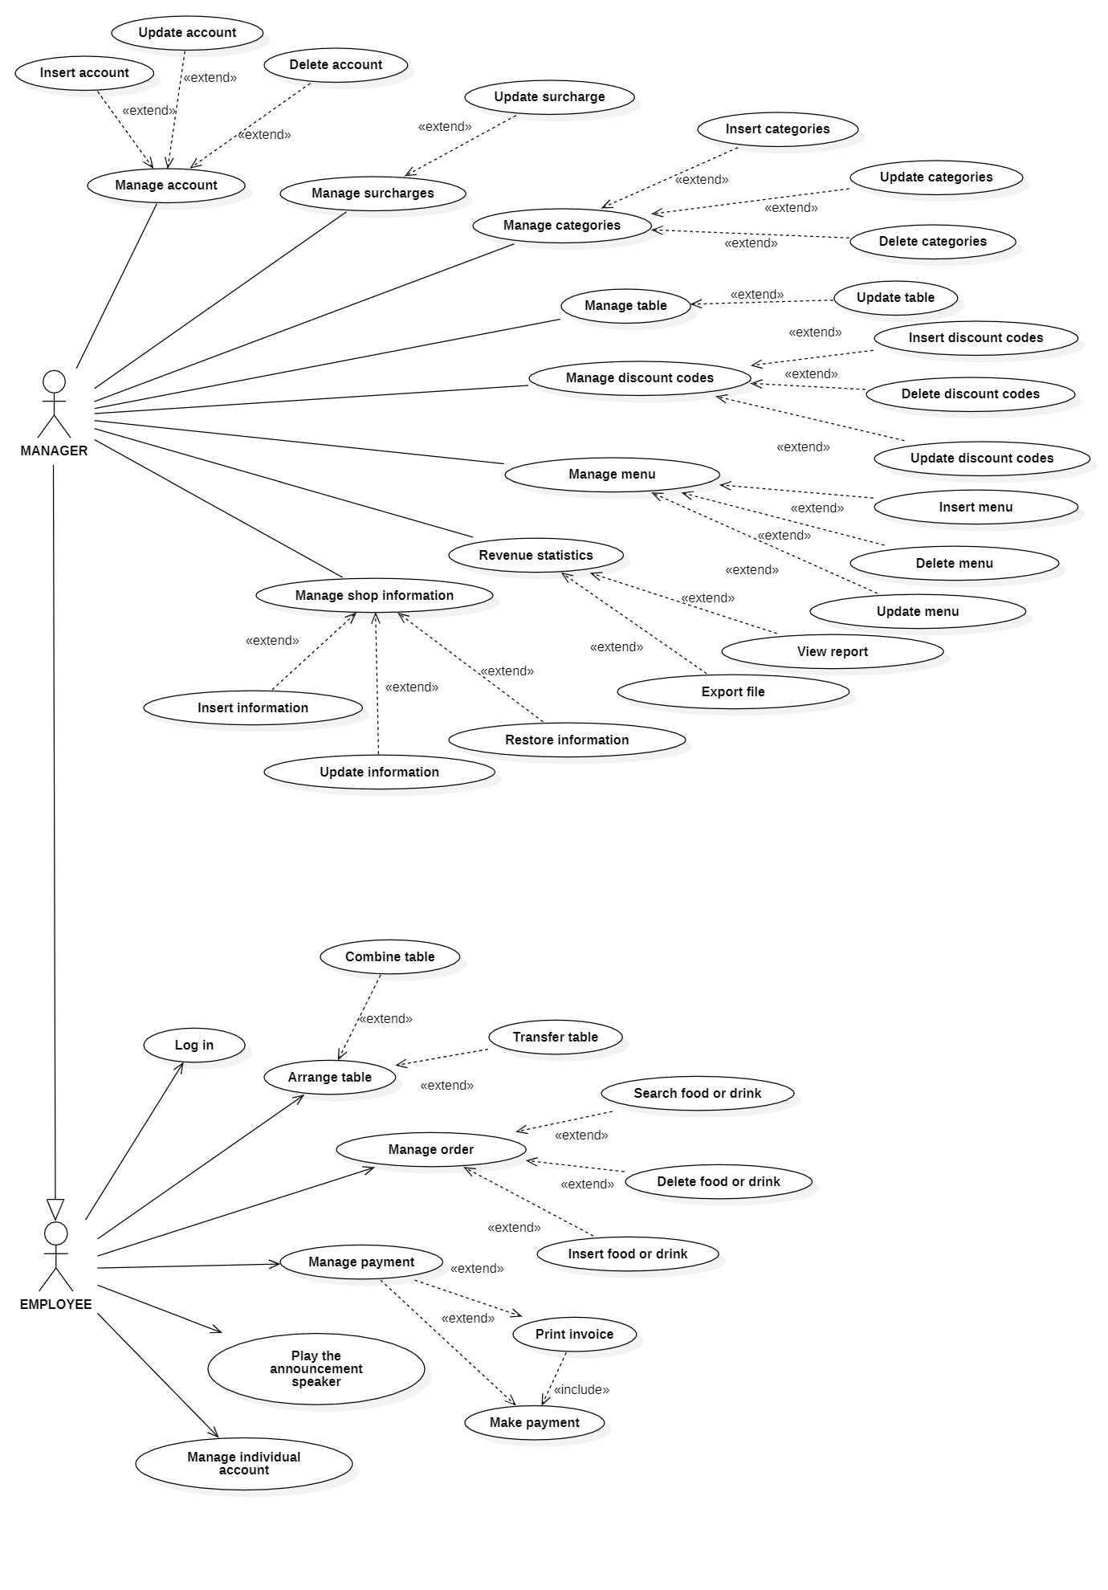

Figure 3.1: Use case diagram

### List of actors

Table 3.1: List of actors

|  |  |  |
| --- | --- | --- |
| **Index** | **Actors** | **Meaning** |
| 1 | Manager | People manage the system and the coffee shop. |
| 2 | Employee | Staff in the cafe. Some features are limited in the system. |

### List of Use-case

3.1.2 List of Use-case

Table 3.2: List of use-case

|  |  |  |  |
| --- | --- | --- | --- |
| Role | Use case | | Meaning |
| Employee | 1 | Login | Log in for using system |
| 2 | Manage individual account | Update the information of individual account. |
| 3 | Manage order | Insert/Delete/Search food or drink |
| 4 | Manage payment | Make payments and print invoices |
| 5 | Arrange table | Transfer or combine table |
| 6 | Play the announcement speaker | Run notifications for the shop. |
| Manager | 7 | Manage account | Mange account in the system such as: Delete/ Update/Insert. |
| 8 | Manage surcharges | Update/ Insert surcharges in coffee shop. |
| 9 | Manage categories | Insert/Update/Delete categories |
| 10 | Manage table | Update the status of the tables. |
| 11 | Manage discount codes | Insert/Update/Delete discount codes for customers |
| 12 | Manage menu | Insert/Update/Delete food and drink in coffee shop. |
| 13 | Revenue statistics | View statistical reports and export sales statistics. |
| 14 | Manage shop information | Insert/Update/Restore shop information (Name of restaurant, contact number, wi-fi information, ...) |

## Use-case specification and activity diagram (Activity Diagram)

### Log in:

Table 3.3: Log in - Use-case specification

|  |  |
| --- | --- |
| Use-case name | Log in |
| Description | Log in for using system. |
| Trigger | Employees click to button “Log in” |
| Pre-condition | Employee must activate the software.  Employee’s account existed |
| Post-condition | Employee redirected to home page and can use services |
| Basic flow | 1. System display log in page.  2. Employee enter username and password  3. System validate employee entered username and password in correct format.  4. System validates employee’s account existed in database.  5. System store login status of employee using sessions.  6. System redirected to home page |
| Alternative flow | 3.a System display invalid notification due to wrong format.  Use-case continues at step 2.  4.a System display invalid notification  due to employee’ account information does not match with existed account information in database.  Use-case continues at step 2. |
| Exception flow |  |

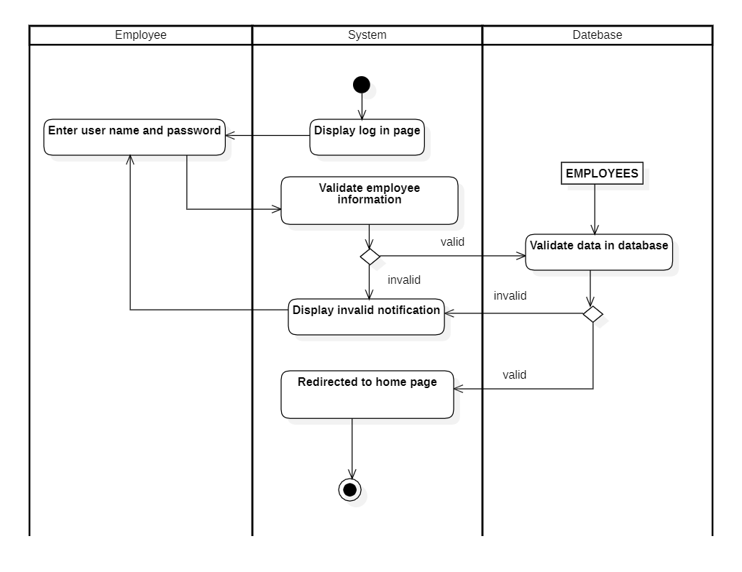

Figure 3.2: Log in - Activity diagram

### Manage individual account:

Table 3.4: Manage individual account - Use-case specification

|  |  |
| --- | --- |
| Use-case name | Manage individual account |
| Description | Update the information of individual account. |
| Trigger | Employee clicks to button “Account” at  management page |
| Pre-condition | Employee must activate the software  Employee’s account existed.  Employee have logged in to the system.  Employee’ account information must be existed in database before updating |
| Post-condition | Data at management is updated (with updated information at selected employee’s account) |
| Basic flow | 1. System display account information management page.  2. Employee enter information to be update  3. System validates employee information entered in correct format.  4. System validates employee password entered in correct in the database.  5. System updates employee information in the database.  6. System displays successful update notification. |
| Alternative flow | 3.a System display invalid notification due to wrong format.  Use-case continues at step 2.  4.a System display invalid notification  due to employee’ password does not match with existed account information in database.  Use-case continues at step 2. |
| Exception flow |  |

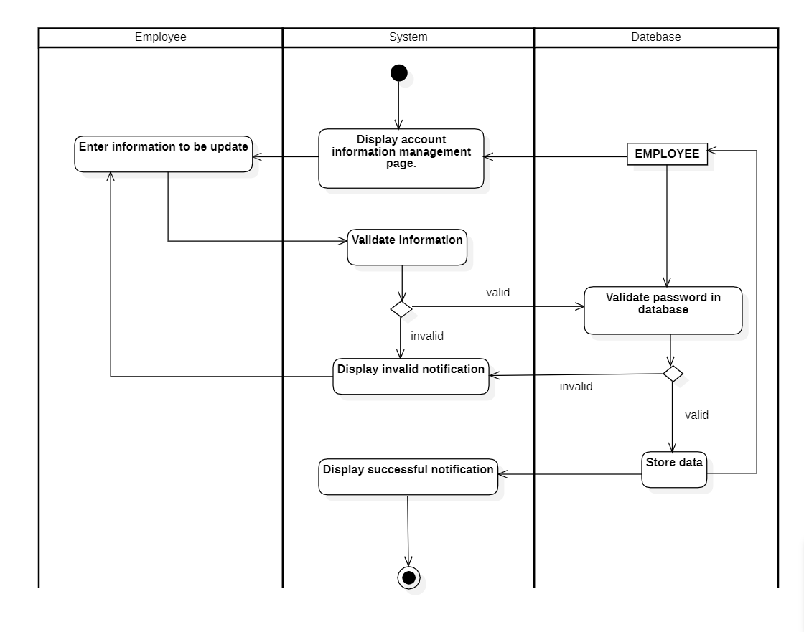

Figure 3.3: Manage individual account - Activity diagram

### Manage order:

Table 3.5: Manage order - Use-case specification

|  |  |
| --- | --- |
| Use-case name | Manage order |
| Description | Insert/Delete/Search food or drink |
| Trigger | Employee chooses a table.  Employee clicks to button “Order” at  management page |
| Pre-condition | Employee must activate the software.  Employee’s account existed.  Employee have logged in to the system  Employee’ account information must be existed in database before updating |
| Post-condition | Data is updated with operate delete, insert.  Data is filtered by keywords. |
| Basic flow | 1. Employee chooses table food and add a new order  2. System display order management page  3. Employee choose a function (delete, insert, search)  - **Insert**  4. Employee choose food and number of food to be inserted.  5. System process insert request.  6. System store data in database  **- Delete**  7. Employee chooses food and number of food to be deleted  8. System process delete data  9. System delete data in database  **- Search**  10. Employee selects search function and enter keywords  11. System process search request  12. System queries data based on keywords  13. System suggested food |
| Alternative flow | 12.a System display error notification due to not found in database. |
| Exception flow |  |

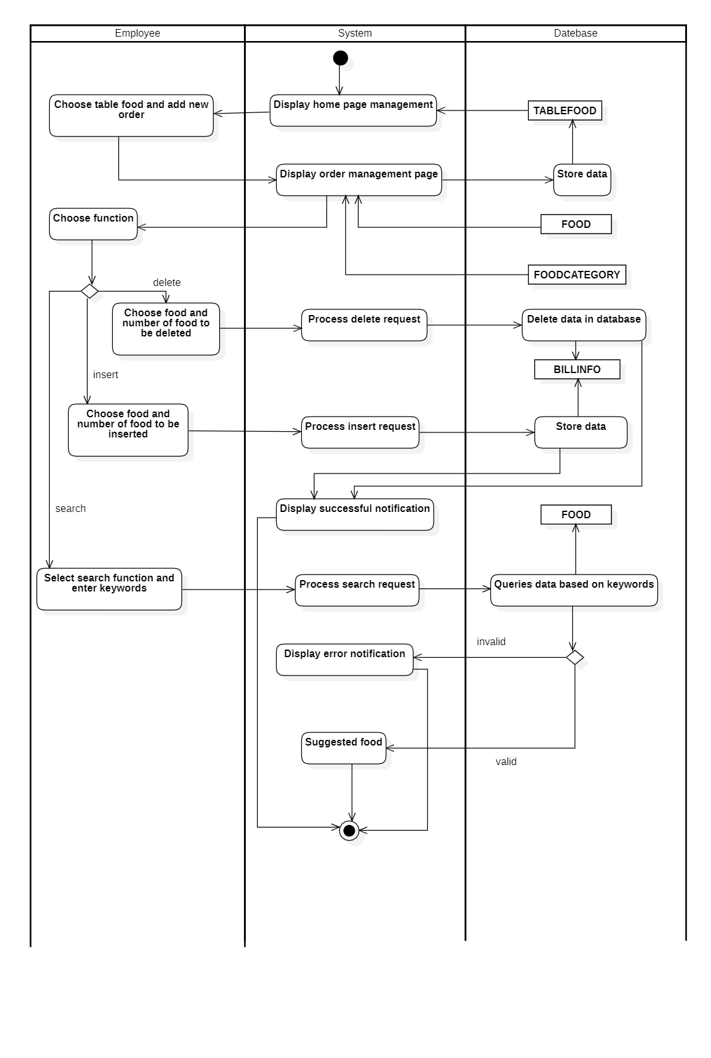

Figure 3.4: Manage order - Activity diagram

### Manage payment:

Table 3.6: Manage payment - Use-case specification

|  |  |
| --- | --- |
| Use-case name | Manage payment |
| Description | Make payments and print invoices |
| Trigger | Employee clicks to button “Payment” at  management page |
| Pre-condition | Employee must activate the software.  Employee’s account existed.  Employee have logged in to the system  Employee’ account information must be existed in database before updating.  The order has been made. |
| Post-condition | The invoice is exported. |
| Basic flow | 1. Employee selects the table to pay and chooses payment.  2. System displays payment management page.  3. Employee enters payment information.  4. System process validate payment information.  5. System process validate payment information  6. System validate in data base  7. System displays valid information  8. Employee confirms payment  10. System displays invoice  11. Employee chooses print  12. System prints invoice |
| Alternative flow | 7.a System display error information due to data empty.  User-case continues at step 3. |
| Exception flow |  |

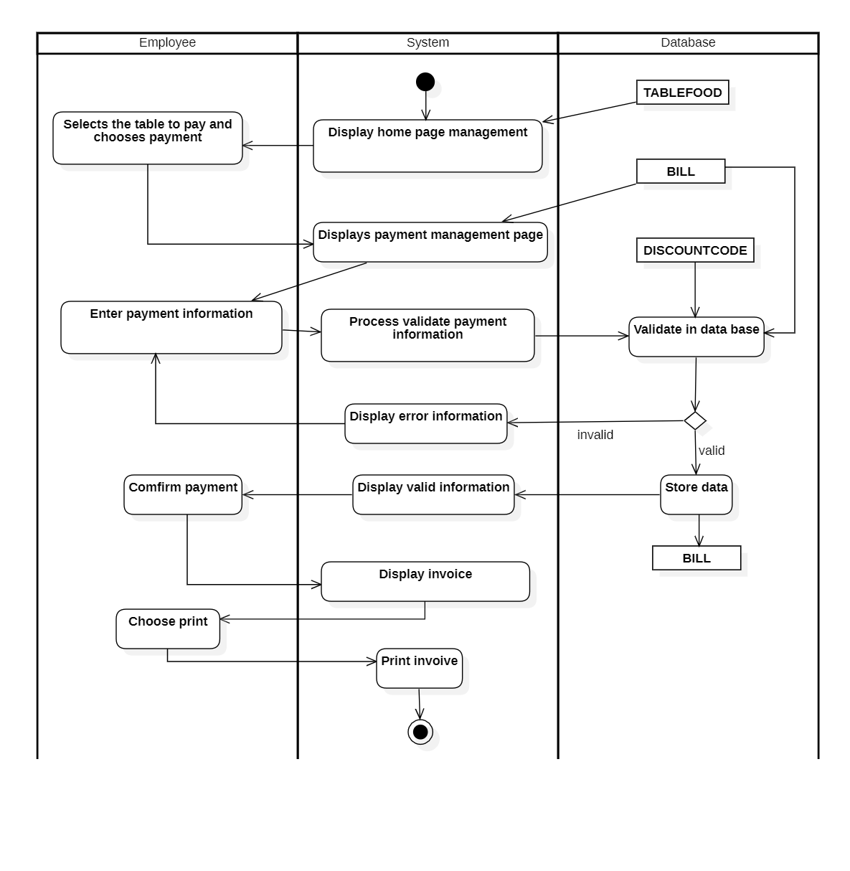

Figure 3.5: Manage payment - Activity diagram

### Arrange table:

Table 3.7: Arrange table - Use-case specification

|  |  |
| --- | --- |
| Use-case name | Arrange table |
| Description | Transfer or combine table |
| Trigger | Employee clicks to button “Combine table” or “Transfer table” at management page |
| Pre-condition | Employee must activate the software.  Employee’s account existed.  Employee have logged in to the system.  Employee’s account information must be existed in database before updating.  The table has been order. |
| Post-condition | Table is combined or transfer. |
| Basic flow | 1. Employee selects a table and choose one function  **- Transfer table**  2. Employee choose transfer table  3. System display transfer management page  4. Employee select a table to transfer and confirm.  5. System process transfer request  6. System updates data in database  7. System display successful notification.  **- Combine table**  8. Employee choose combine table  9. System display combine management page  10. Employee select table to combine and confirm.  11. System process combine request  12. System updates data in database  13. System display successful notification. |
| Alternative flow |  |
| Exception flow |  |

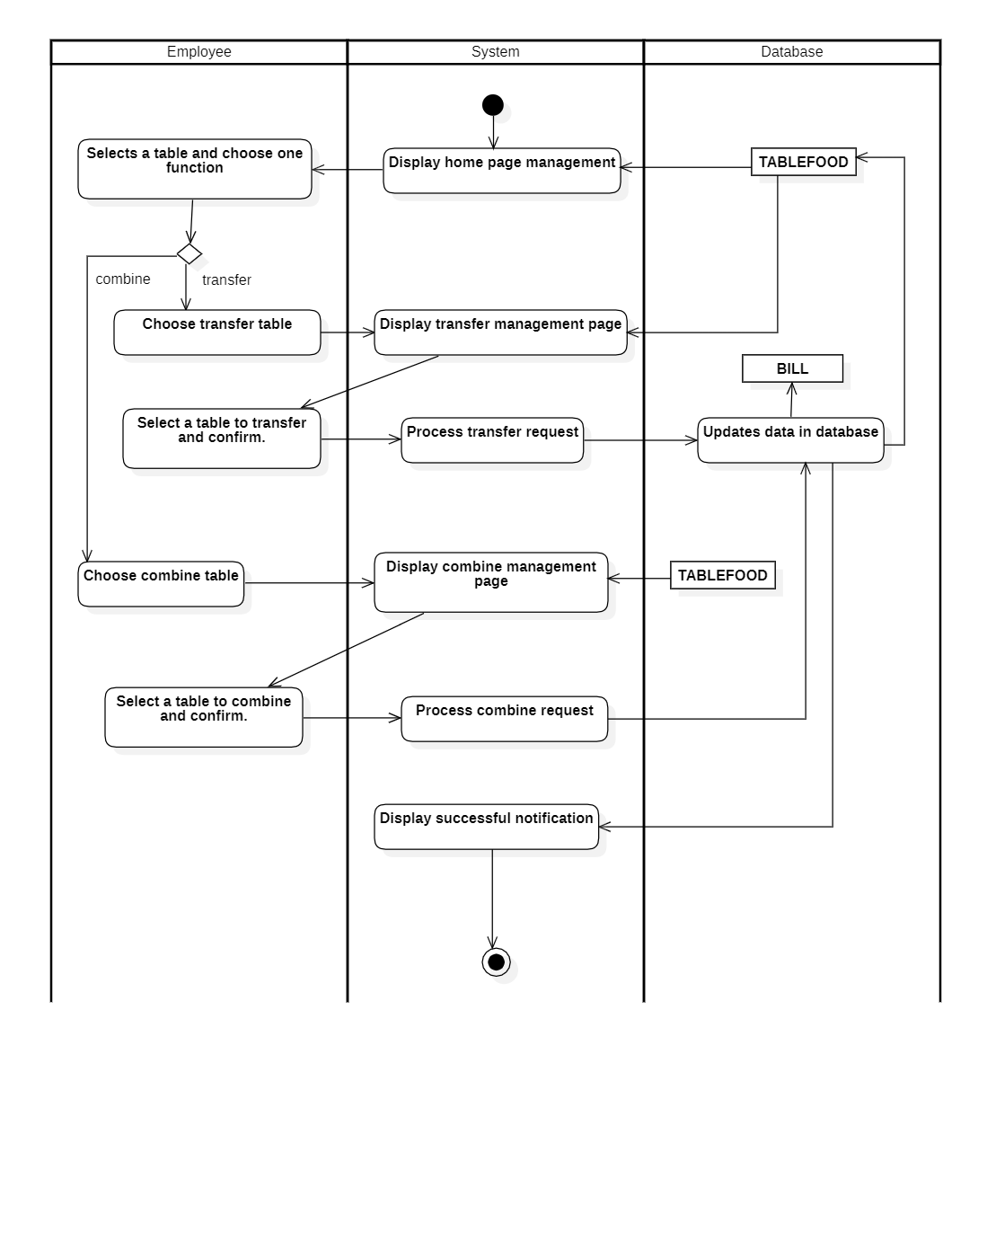

Figure 3.6: Arrange table - Activity diagram

### Play the announcement speaker:

Table 3.8: Play the announcement speaker - Use-case specification

|  |  |
| --- | --- |
| Use-case name | Play the announcement speaker |
| Description | Run notifications for the shop. |
| Trigger | Employee clicks to button “Notification” at management page |
| Pre-condition | Employee must activate the software.  Employee’s account existed.  Employee have logged in to the system.  Employee ‘s account information must be existed in database before updating. |
| Post-condition | Announcement is issued |
| Basic flow | 1.Employee choose notification  2. System display announcement management page  3. Employee select one notification  4. System process notification request  5. System get notification in database  6. System issued notification. |
| Alternative flow |  |
| Exception flow |  |

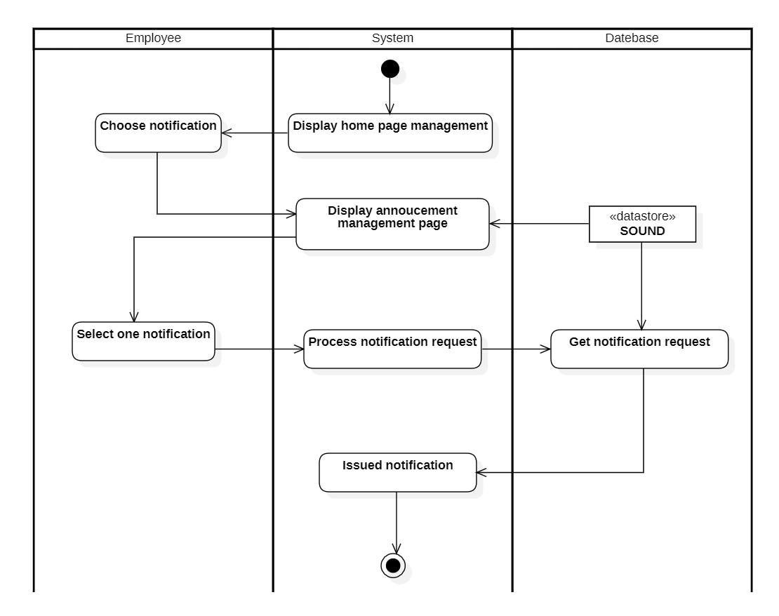

Figure 3.7: Play the announcement speaker - Activity diagram

### Manage account:

Table 3.9: Manage account - Use-case specification

|  |  |
| --- | --- |
| Use-case name | Manage account |
| Description | Manager can insert, delete, update accounts information. |
| Trigger | Manager clicks tab “Account” to manage accounts information. |
| Pre-condition | The manager must be signed in as Manager. |
| Post-condition | Manager gets a list of account with detail information.  With insert or delete or update discount code, list of accounts is updated. |
| Basic flow | 1. System display admin page. 2. Manager chooses tab “Account”. 3. System displays list of accounts in account tab. 4. Managers choose the respective functions (one of the insert, update, delete or view)  * Insert  1. Managers enter accounts information. 2. System validates accounts information with existed data in database. 3. System stores accounts information in database. 4. System displays successful notification and reloads list of accounts at tab.  * Update  1. Managers chooses account to be updated. 2. System display account in tab. 3. Managers modify account information. 4. System validates account information with existed data in database. 5. System stores account information in database. 6. System displays successful notification and reloads list of accounts at tab.  * Delete  1. Manager chooses account to be deleted. 2. System process delete request. 3. System deletes account information in database. 4. System displays successful notification and reloads accounts tab at admin page. |
| Alternative flow | 7a. System display invalid information because data had been existed in the database. Use-case continue at step 6.    13a. System display invalid information because data had been existed in the database. Use-case continue at step 12. |
| Exception flow |  |

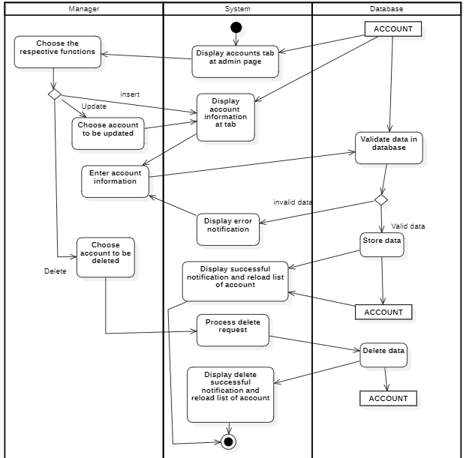Figure 3.8: Manage account - Activity diagram

### Manage surcharges:

Table 3.10: Manage surcharges - Use-case specification

|  |  |
| --- | --- |
| Use-case name | Manage surcharges |
| Description | Manager can update surcharge information. |
| Trigger | Manager clicks tab “Surcharge” to manage surcharges information. |
| Pre-condition | The manager must be signed in as Manager. |
| Post-condition | With update: Data in database is updated. |
| Basic flow | 1. System display admin page. 2. Manager chooses tab “Surcharge”. 3. System displays information of surcharge in tab. 4. Managers choose the information to update (one or more: type, hour, day or days in week)  * Type  1. Managers modify type of surcharge. 2. System stores type in database. 3. System displays successful notification and displays surcharge tab at admin page.  * Hour  1. Managers modify time of surcharge*.* 2. System stores hour in database. 3. System displays successful notification and displays information at tab.  * Day  1. Managers modify day for surcharge. 2. System stores day in database. 3. System displays successful notification and displays information at tab.  * Days in week  1. Managers modify days in week of surcharge. 2. System stores days in week in database. 3. System displays successful notification and displays information at tab. |
| Alternative flow |  |
| Exception flow |  |

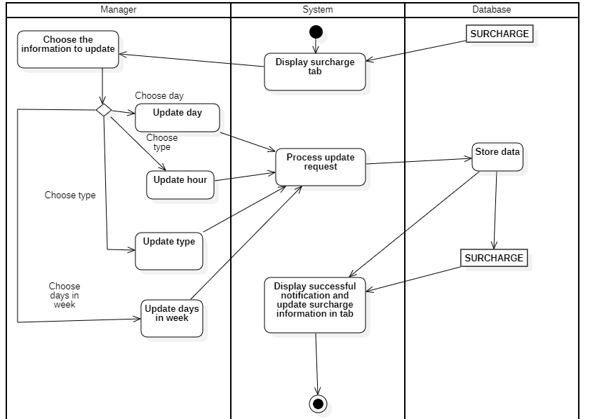

*Figure 3.9: Manage surcharges - Activity diagram*

### Manage categories:

Table 3.11: Manage categories - Use-case specification

|  |  |
| --- | --- |
| Use-case name | Manage categories |
| Description | Manager can insert, delete, update categories information. |
| Trigger | Manager clicks tab “Category” to manage categories information. |
| Pre-condition | The manager must be signed in as Manager. |
| Post-condition | Manager gets a list of categories with detail information.  With insert or delete or update discount code, list of categories is updated. |
| Basic flow | 1. System display admin page. 2. Manager chooses tab “Category”. 3. System displays list of categories in category tab. 4. Manager choose the respective functions (one of the insert, update, delete or view)  * Insert  1. Manager enter categories information. 2. System validates categories information with existed data in database. 3. System stores categories information in database. 4. System displays successful notification and reloads list of categories at tab.  * Update  1. Managers chooses category to be updated. 2. System display category in tab. 3. Managers modify category information. 4. System validates category information with existed data in database. 5. System stores category information in database. 6. System displays successful notification and reloads list of categories at tab.  * Delete  1. Manager chooses category to be deleted. 2. System process delete request. 3. System deletes category information in database. 4. System displays successful notification and reloads categories tab at admin page. |
| Alternative flow | 7a. System display invalid information because data had been existed in the database. Use-case continue at step 6.    13a. System display invalid information because data had been existed in the database. Use-case continue at step 12. |
| Exception flow |  |

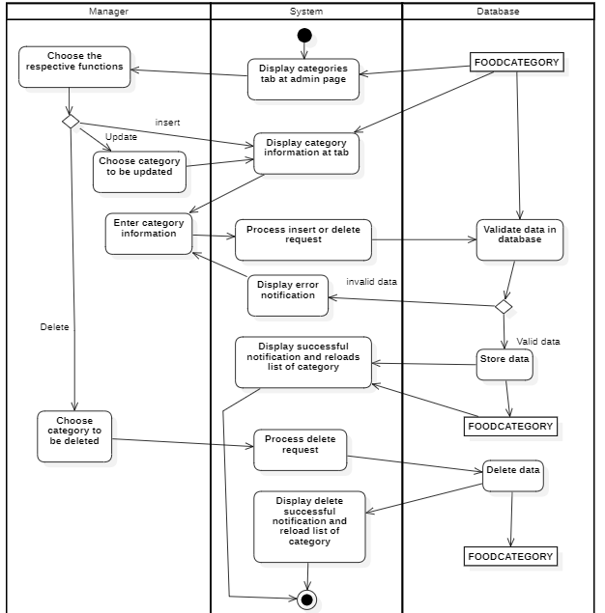Figure 3.10: Manage categories - Activity diagram

### Manage table:

Table 3.12: Manage table - Use-case specification

|  |  |
| --- | --- |
| Use-case name | Manage table |
| Description | Manager can update tables information. |
| Trigger | Manager clicks to tab “Table” to manage tables information |
| Pre-condition | The manager must be signed in as Manager. |
| Post-condition | With update: Data in database is updated. |
| Basic flow | 1. System display admin page. 2. Manager chooses tab “Table”. 3. System displays list of tables in tab. 4. Managers choose the table to update. 5. System displays table in tab. 6. Managers modify table information. 7. System validates table information with existed data in database. 8. System stores table information in database. 9. System displays successful notification and reloads list of tables at tab. |
| Alternative flow | 7a. System display invalid information because data had been existed in the database. Use-case continue at step 6. |
| Exception flow |  |

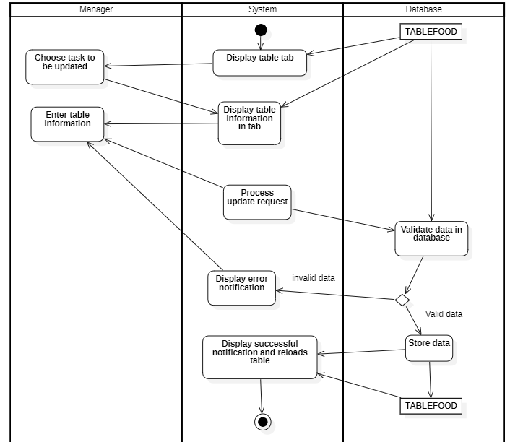Figure 3.11: Manage table - Activity diagram

### Manage discount codes:

Table 3.13: Manage discount codes - Use-case specification

|  |  |
| --- | --- |
| Use-case Name | Manage Discount codes |
| Description | Add, delete, update discount code. |
| Trigger | Manager click tab “Code” in admin page. |
| Pre-Condition | User must signed-in with manager account. |
| Post-Condition | Manager gets a list of discount codes with detail information  If manager add or delete or update discount code, list of discount codes is updated. |
| Basic Flow | 1. Click “Admin” in menu. 2. System displays admin page. 3. Manager chooses tab “Code”. 4. System display list of discount codes. 5. Choose one function (insert/update/delete).   **- Insert:**   1. Manager enter discount code information. 2. System validates discount code information with existed data in database. 3. System stores discount code information in database. 4. System displays successful notification and reload list of discount code.   **- Update:**   1. Manager choose discount code to be updated. 2. System display discount code information. 3. Manager enter discount code information. 4. System validates discount code information with existed data in database. 5. System stores discount code information in database. 6. System displays successful notification and reload list of discount code.   **- Delete**   1. Manager choose discount code to be deleted. 2. System progresses delete request. 3. System delete discount code information in database. 4. System displays delete successful notification and reload list of discount code. |
| Alternative Flow | 7a. System displays invalid information because data had been existed in the database. Use-case continue at step 6.  13a. System displays invalid information because data had not been existed in the database. Use-case continue at step 12. |
| Extension Flow |  |

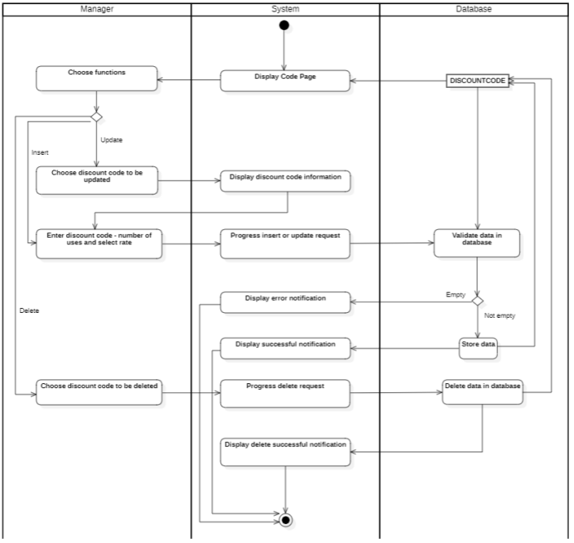

Figure 3.12: Manage discount codes - Activity diagram

### Manage menu:

Table 3.14: Manage menu - Use-case specification

|  |  |
| --- | --- |
| Use-case Name | Manage menu |
| Description | Add, delete, update food and drink. |
| Trigger | Manager click tab “Food” in admin page. |
| Pre-Condition | User must signed-in with manager account. |
| Post-Condition | Manager gets a list of food with detail information.  If manager add or delete or update food, list of food is updated. |
| Basic Flow | 1. Click “Admin” in menu. 2. System displays admin page. 3. Manager chooses tab “Food”. 4. System display list of Food. 5. Choose one function (insert/update/delete).   **- Insert:**   1. Manager enter food information. 2. System stores food information in database. 3. System displays successful notification and reload list of food.   **- Update:**   1. Manager choose food to be updated. 2. System display food information. 3. Manager enter food information. 4. System stores food information in database. 5. System displays successful notification and reload list of food.   **- Delete**   1. Manager choose food to be deleted. 2. System progresses delete request. 3. System delete food information in database. 4. System displays delete successful notification and reload list of food. |
| Alternative Flow |  |
| Extension Flow |  |

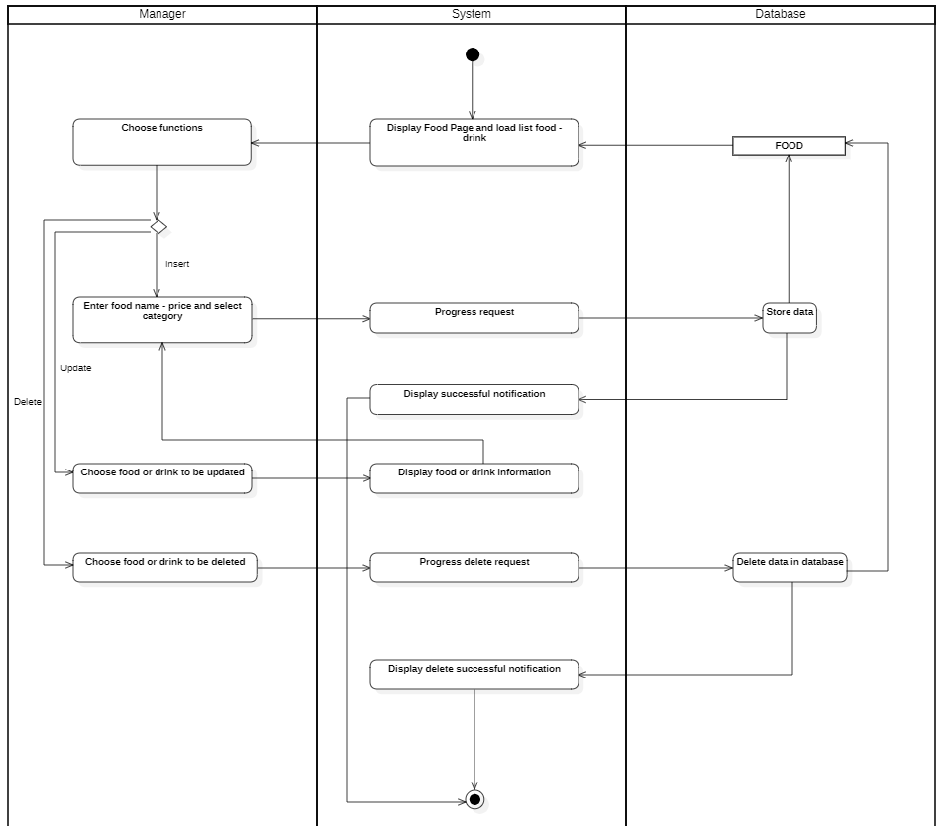

Figure 3.13: Manage menu - Activity diagram

### Revenue statistics:

Table 3.15: Manage statistics - Use-case specification

|  |  |
| --- | --- |
| Use-case Name | Revenue statistics |
| Description | View statistical reports and export sales statistics. |
| Trigger | Manager click tab “Revenue” in admin page. |
| Pre-Condition | User must signed-in with manager account. |
| Post-Condition | Manager gets a list of bills with time.  If manager select check-in or check-out, list of bill and total are updated. |
| Basic Flow | 1. Click “Admin” in menu. 2. System displays admin page. 3. Manager chooses tab “Revenue”. 4. Manager chooses start time and end time. 5. System validates start - end time information with existed data in database. 6. System displays list of bill and total revenue. 7. Manager chooses to export file. 8. System display excel file. |
| Alternative Flow | 5a. System displays invalid information because start time > end time. Use-case continue at step 4. |
| Extension Flow |  |

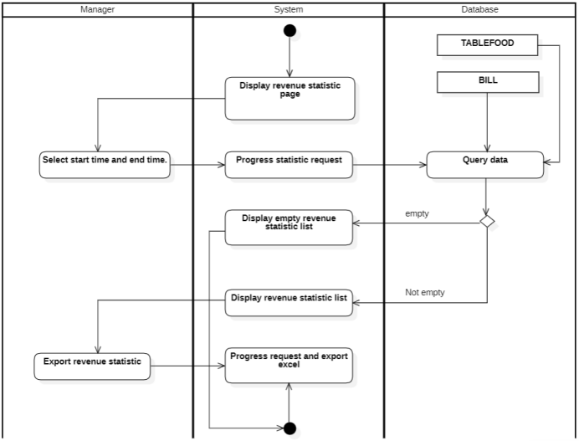

Figure 3.14: Revenue statistics - Activity diagram

### Manage shop information:

Table 3.16: Manage shop information - Use-case specification

|  |  |
| --- | --- |
| Use-case Name | Manage shop information |
| Description | Manage shop information (Name of restaurant, contact number, wi-fi information, ...). |
| Trigger | Manager click tab “Shop” in admin page. |
| Pre-Condition | User must signed-in with manager account. |
| Post-Condition | Manager gets detail shop information. |
| Basic Flow | 1. Click “Admin” in menu. 2. System displays admin page. 3. Manager chooses tab “Shop”. 4. System display shop information. 5. Choose one function (set up/restore).   **- Set up:**   1. Manager enter shop information. 2. System validates shop information. 3. System stores shop information in database. 4. System displays successful notification and display shop information page.   **- Restore:**   1. Manager choose button restore. 2. System gets shop information in database. 3. System displays shop information page. |
| Alternative Flow | 5a. System displays invalid information because invalid data. Use-case continue at step 4. |
| Extension Flow |  |

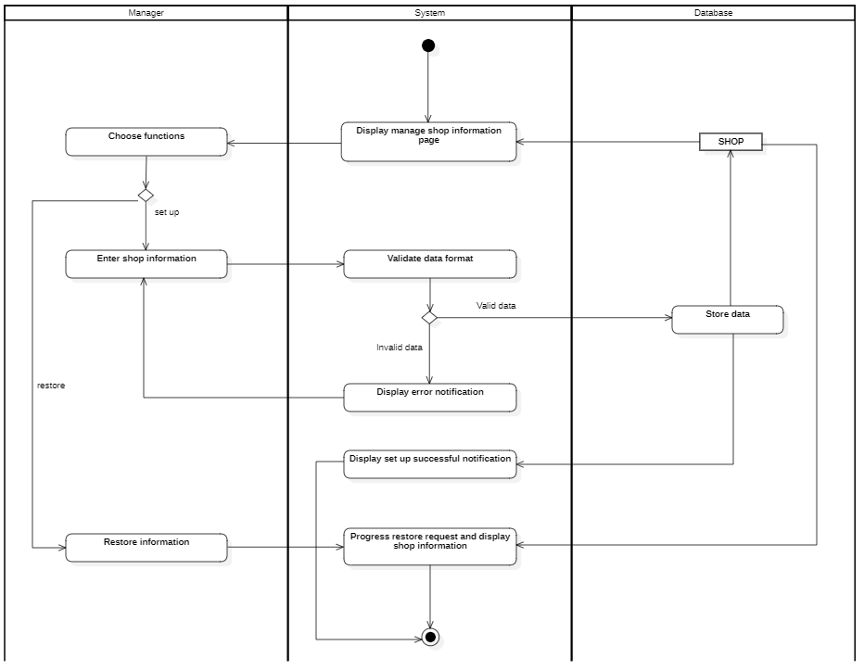

Figure 3.15: Manage shop information - Activity diagram

## Sequence Diagram and Class Diagram

### Log in

#### Sequence diagram

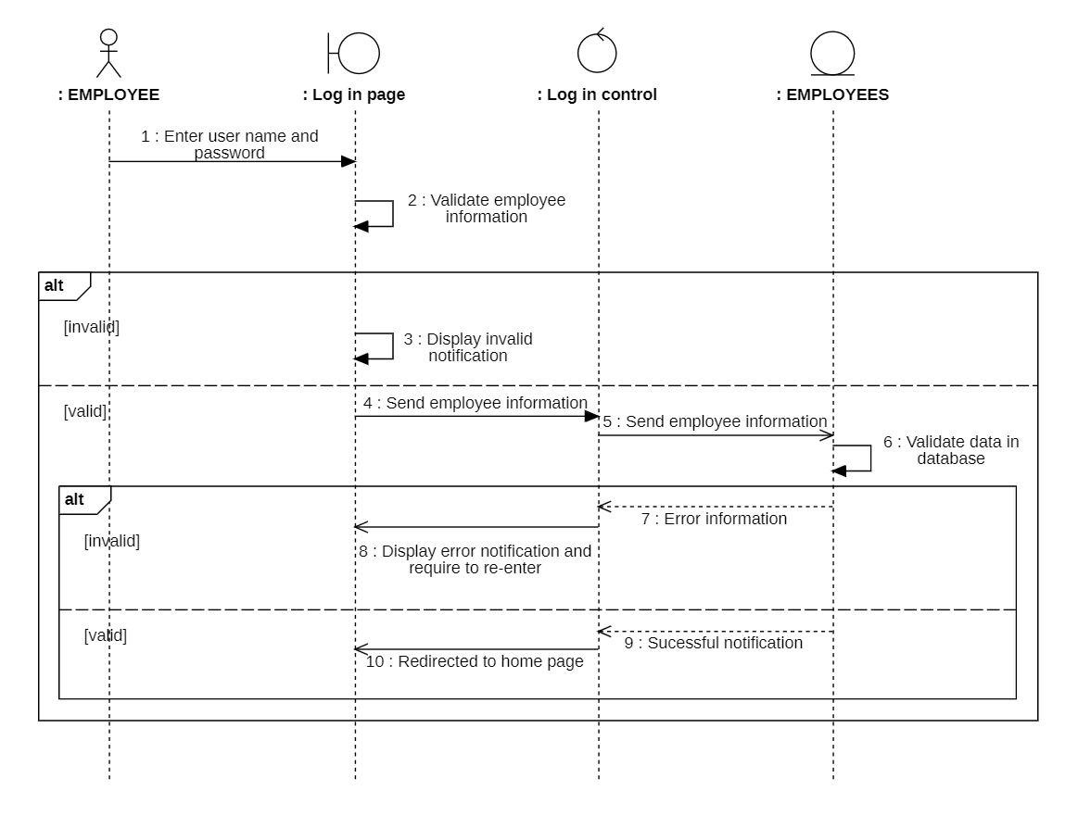Figure 3.16: Log in - Sequence diagram

#### Class Diagram

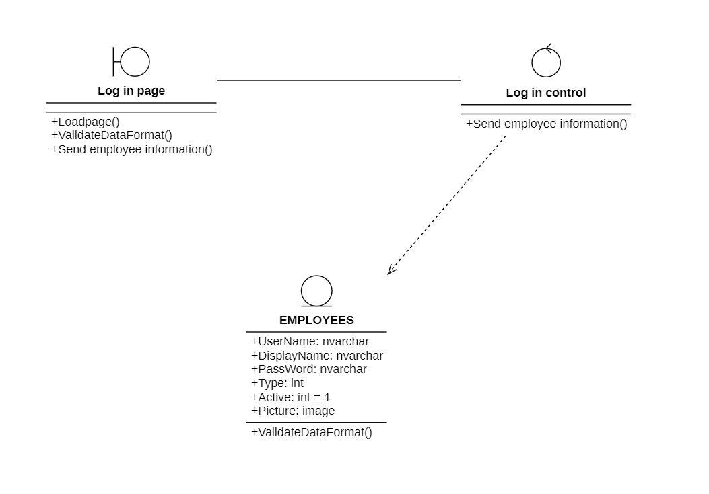Figure 3.17: Log in - Class diagram

### Manage individual account

#### Sequence diagram

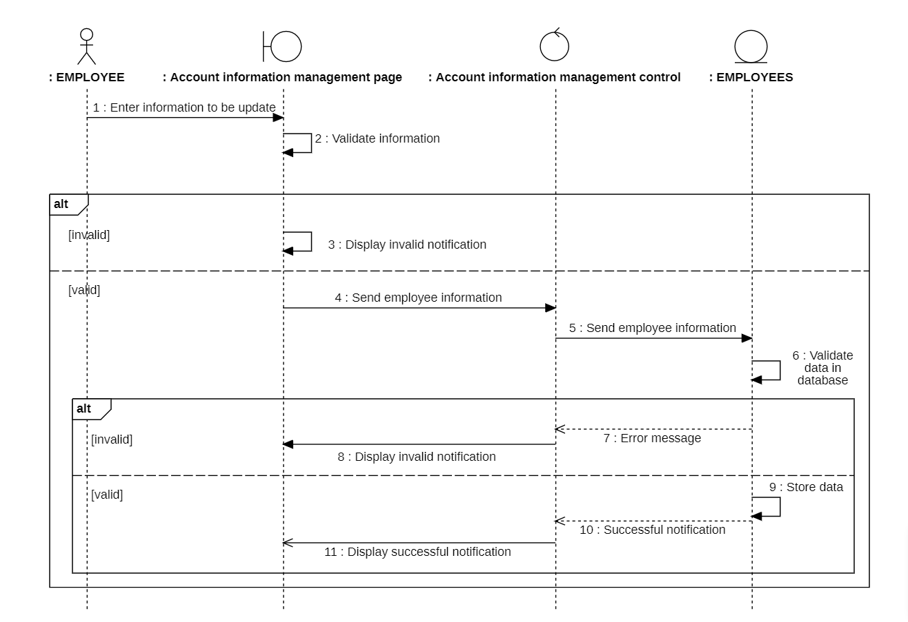Figure 3.18: Manage individual account - Sequence diagram

#### Class Diagram

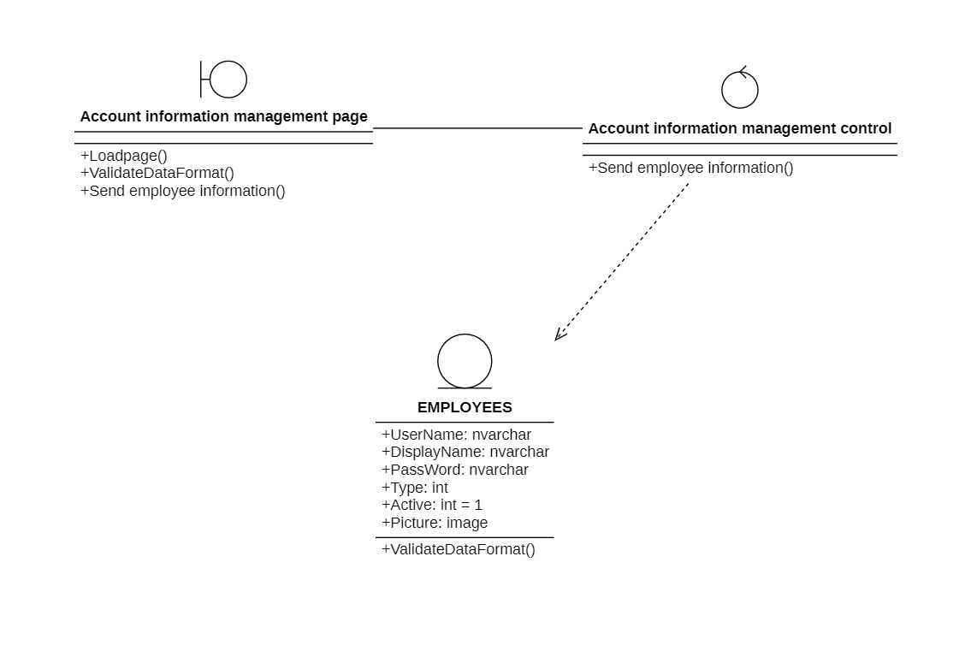Figure 3.19: Manage individual account - Class diagram

### Manage order

#### Sequence diagram

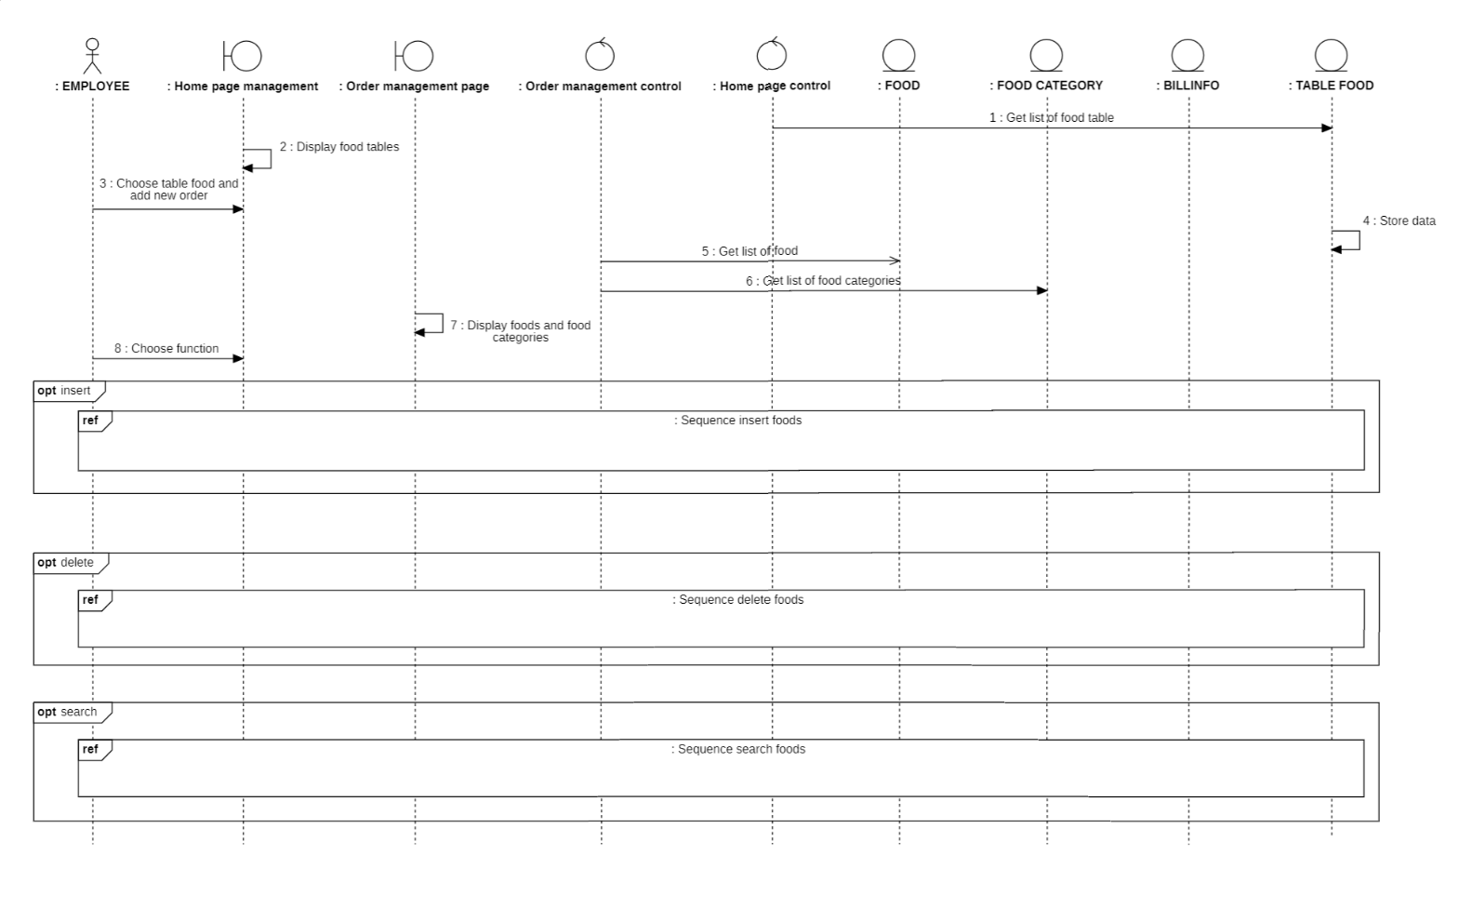Figure 3.20: Manage order - Sequence diagram

1. Insert

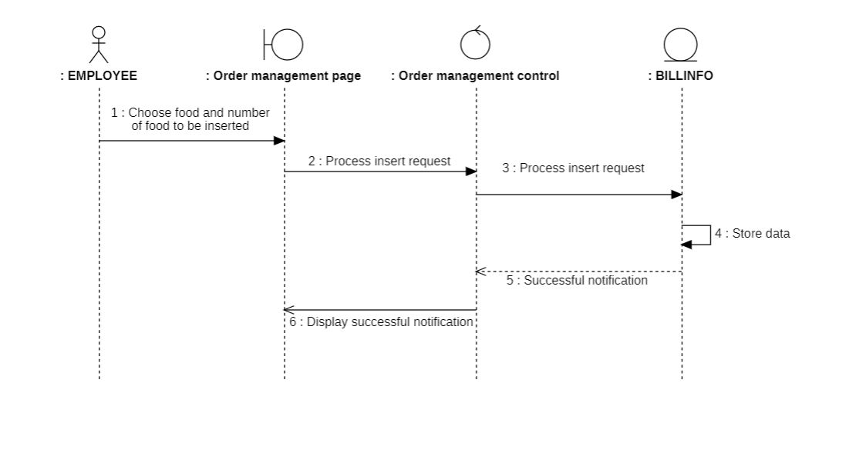Figure 3.21: Insert order - Sequence diagram

1. Delete

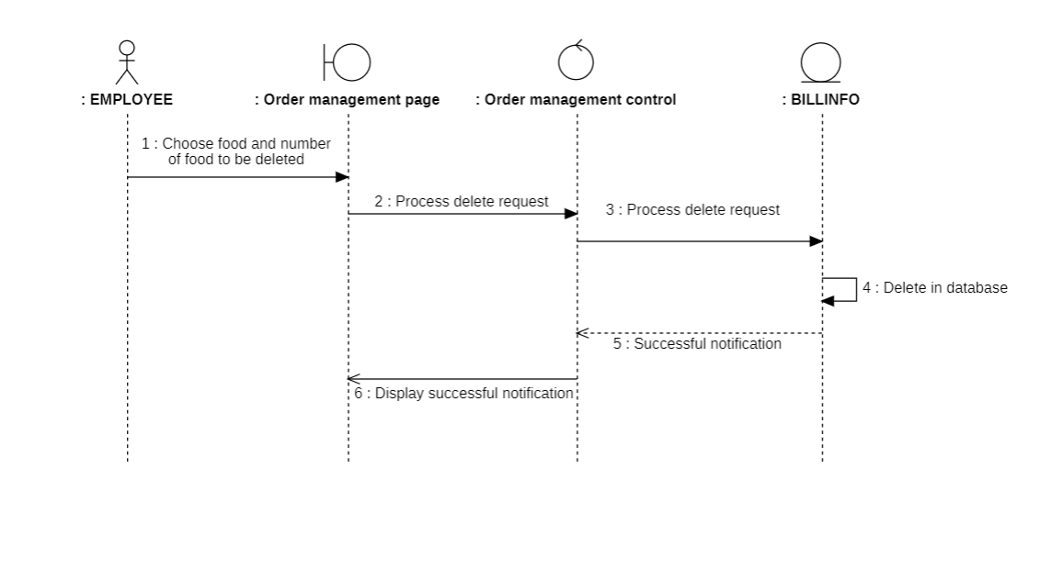Figure 3.22: Delete order - Sequence diagram

1. Search

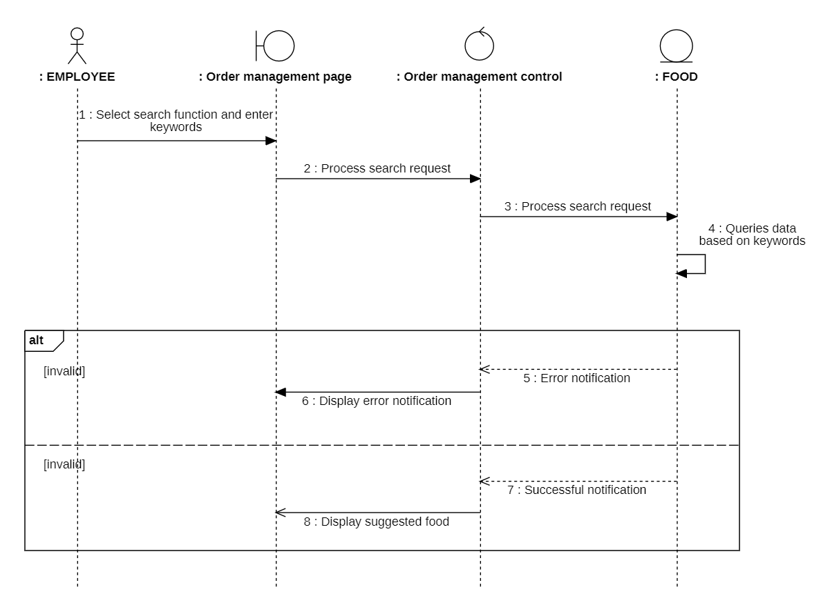Figure 3.23: Search order - Sequence diagram

#### Class Diagram

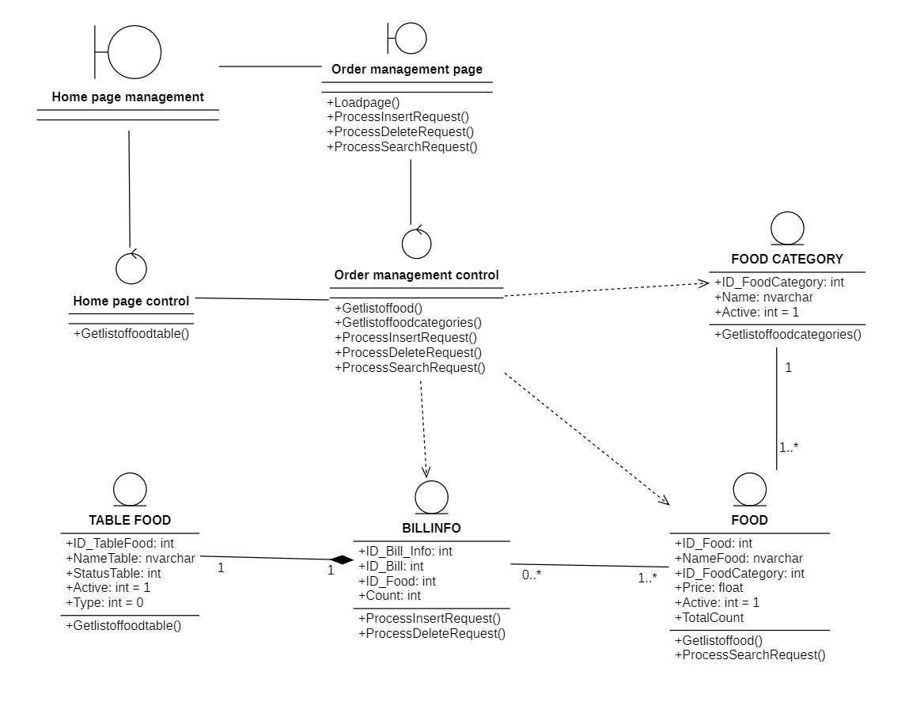Figure 3.24: Manage order - Class diagram

### Manage payment:

#### Sequence diagram:

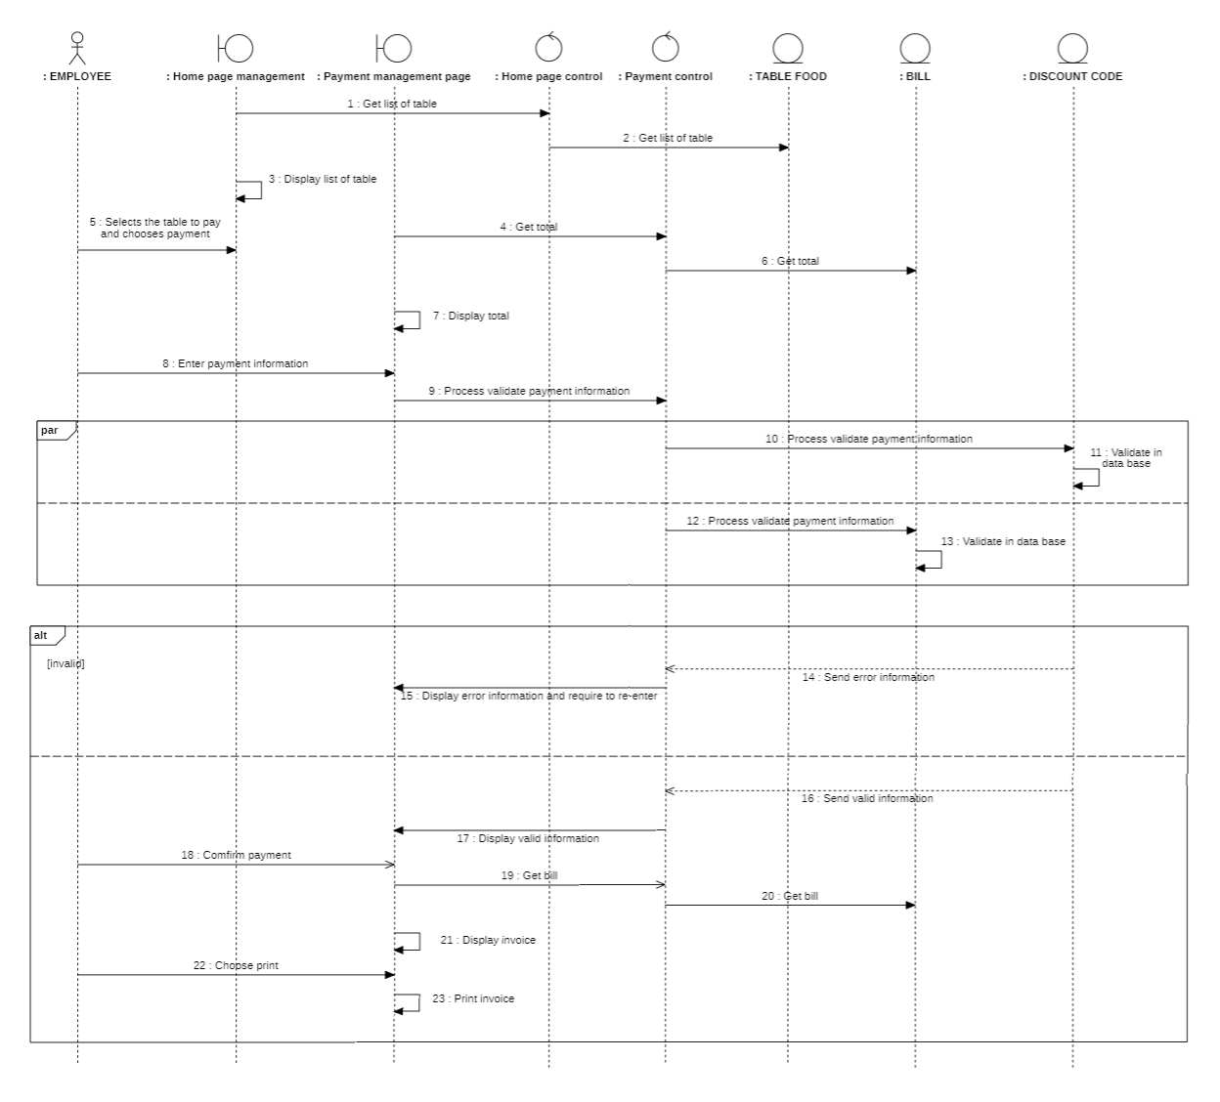Figure 3.25: Manage payment - Sequence diagram

#### Class diagram:

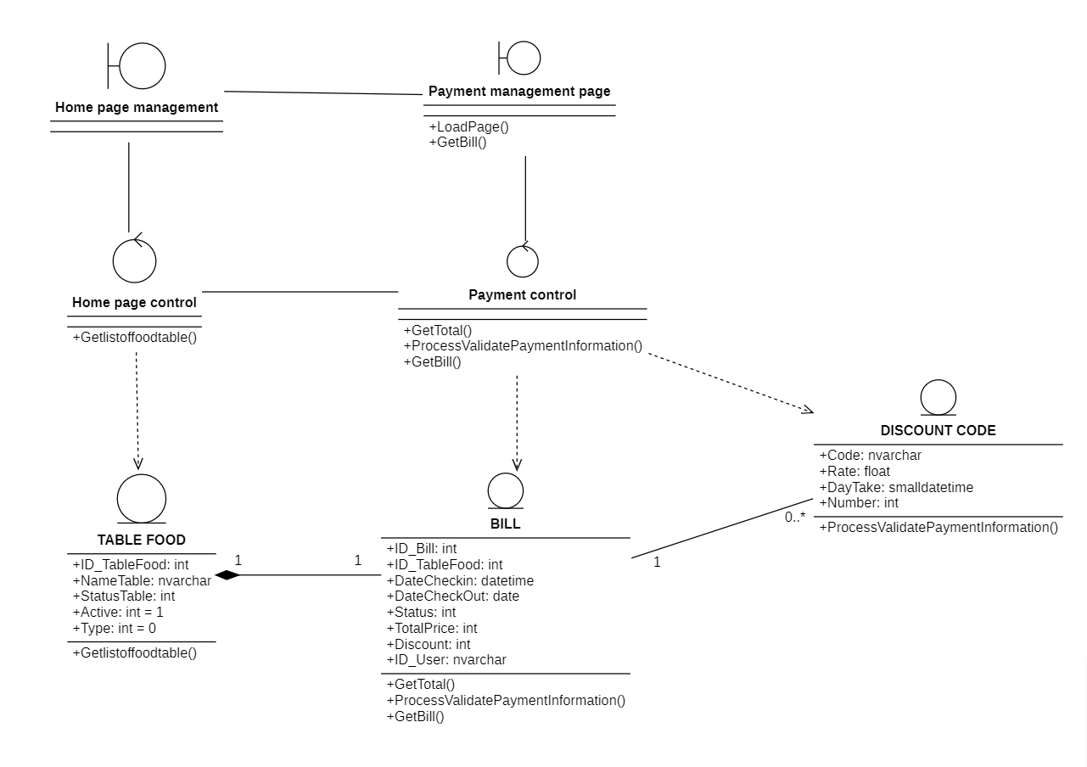Figure 3.26: Manage payment - Class diagram

### Arrange table:

#### Sequence diagram

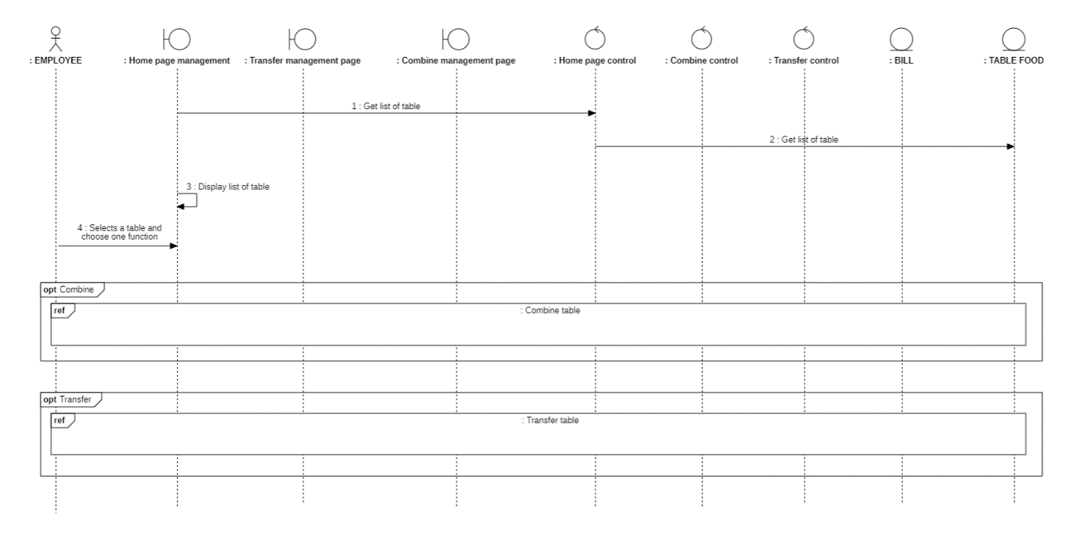Figure 3.27: Arrange table - Sequence diagram

1. Combine table

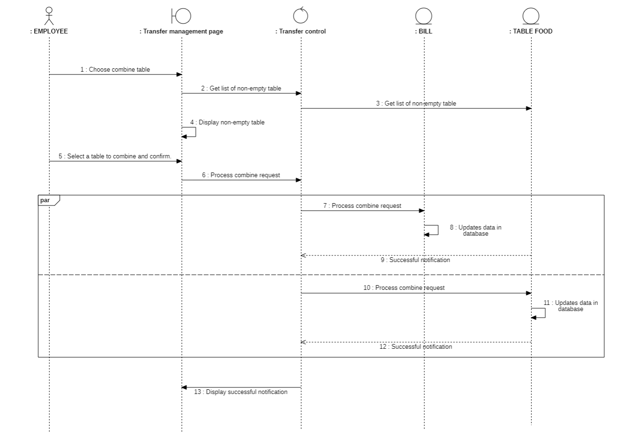Figure 3.28: Combine table - Sequence diagram

1. Transfer table

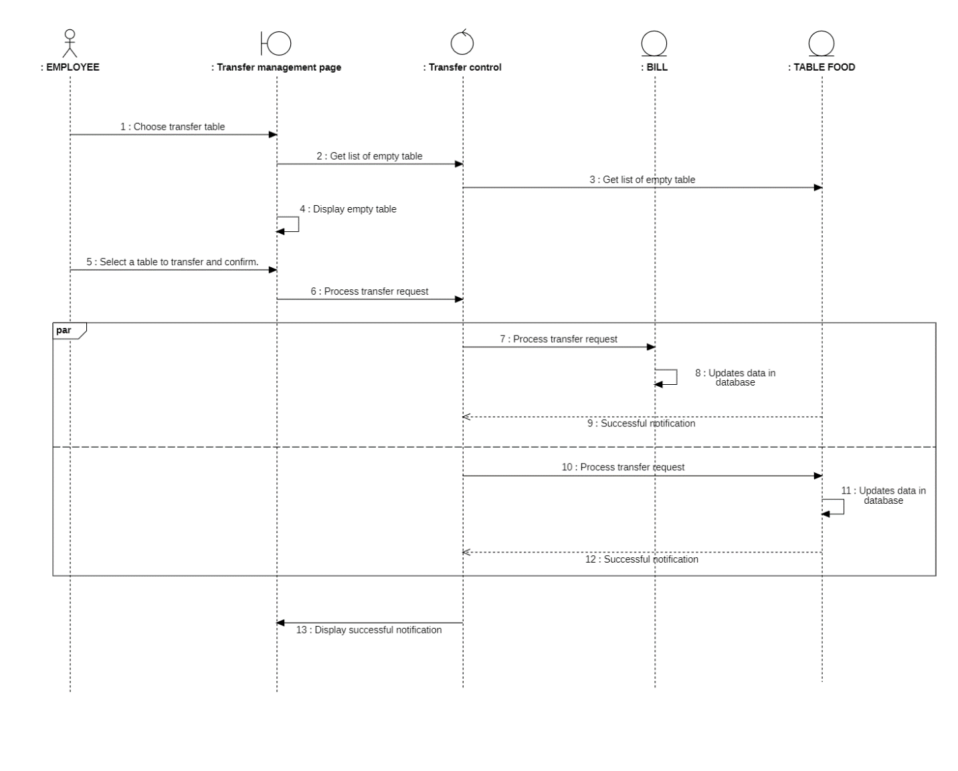Figure 3.29: Transfer table - Sequence diagram

#### Class diagram:

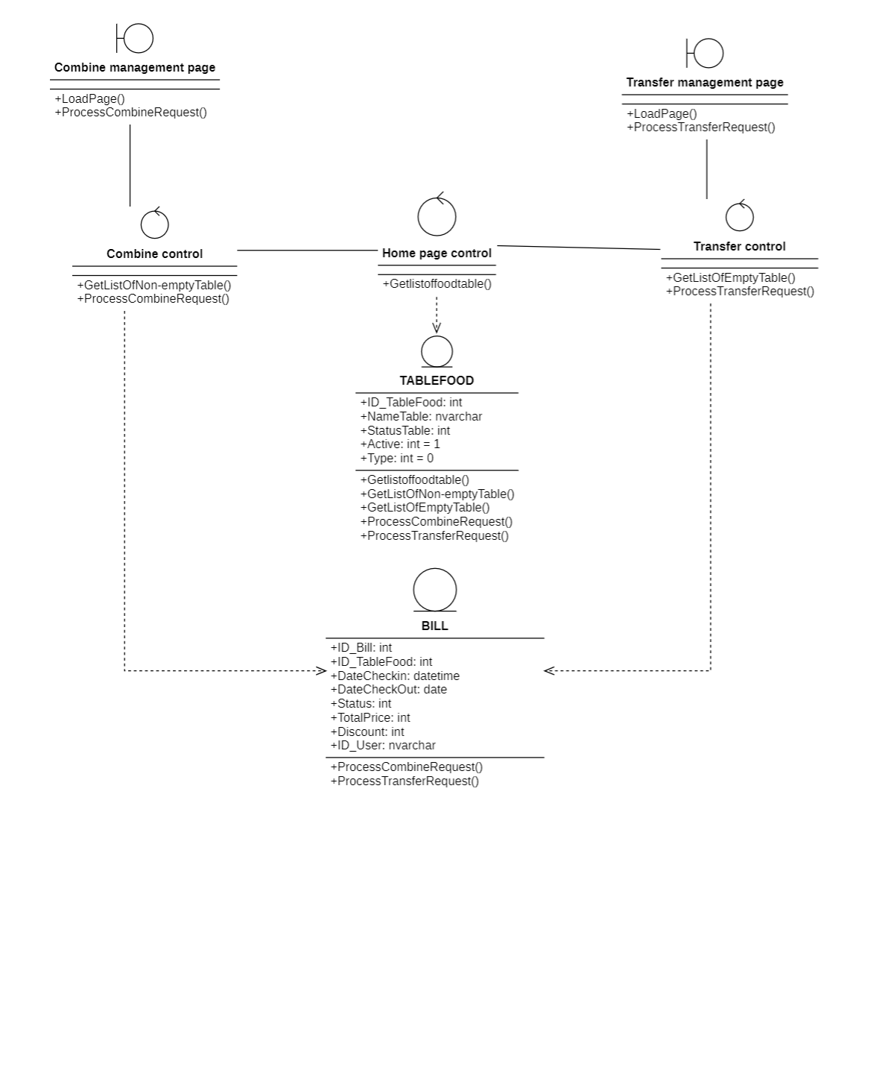

Figure 3.30: Arrange table - Class diagram

### Play the announcement speaker:

#### Sequence diagram:

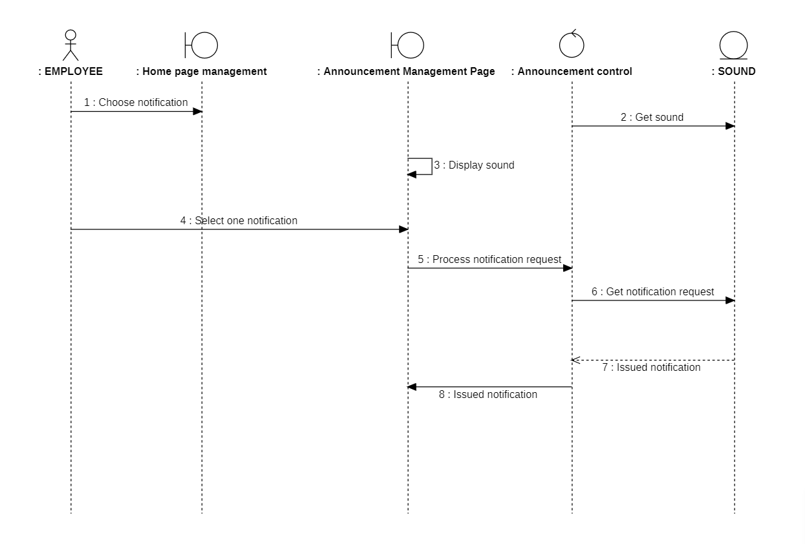Figure 3.31: Play the announcement speaker - Sequence diagram

#### Class diagram:

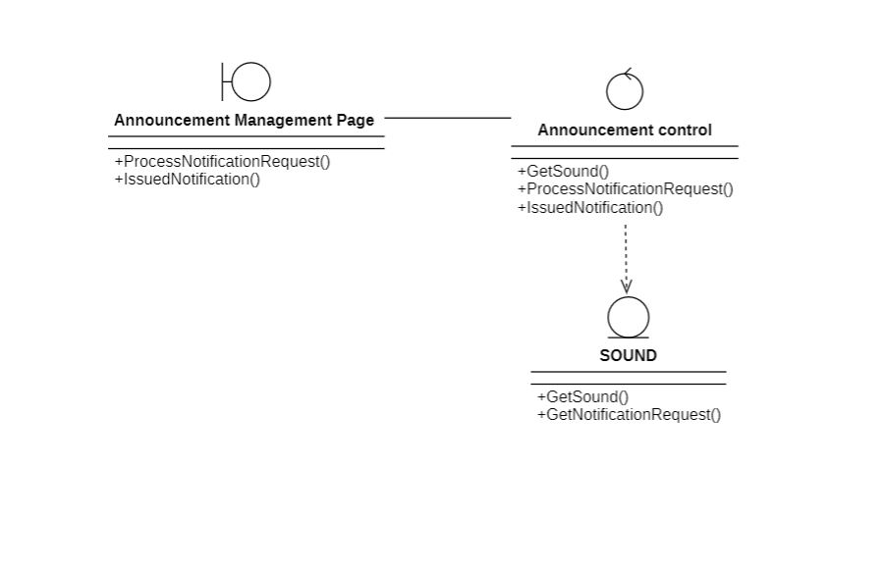

Figure 3.32: Play the announcement speaker - Class diagram

### Manage account:

#### Sequence diagram:

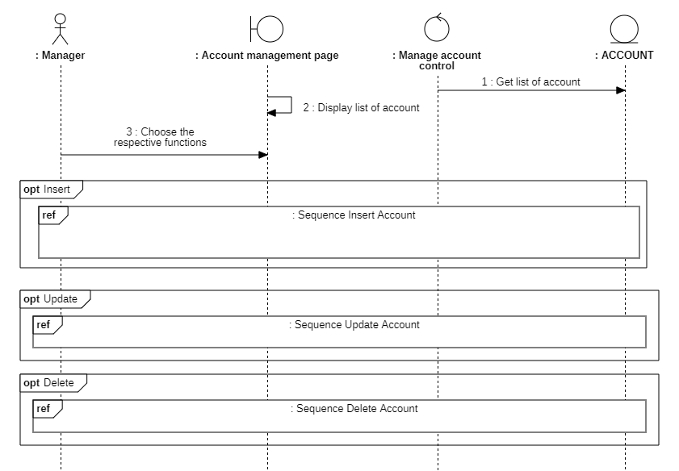 Figure 3.33: Manage account - Sequence diagram

1. Insert

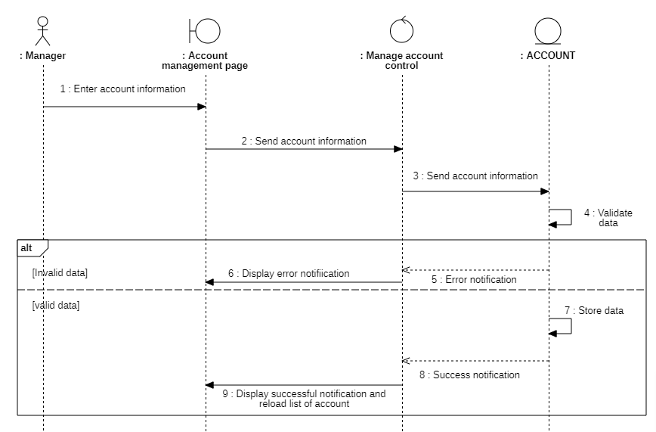 Figure 3.34: Insert account - Sequence diagram

1. Update

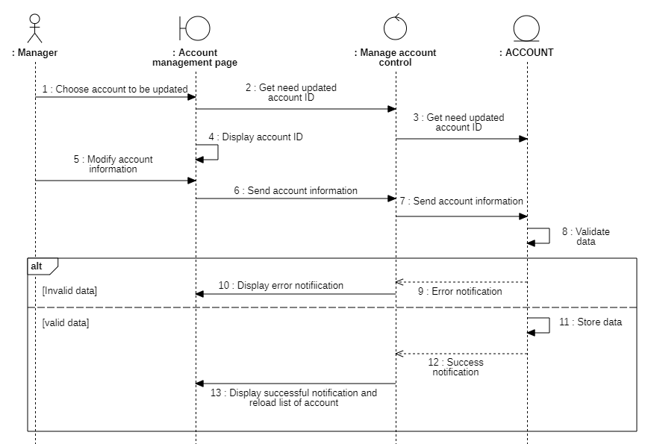 Figure 3.35: Update account - Sequence diagram

1. Delete

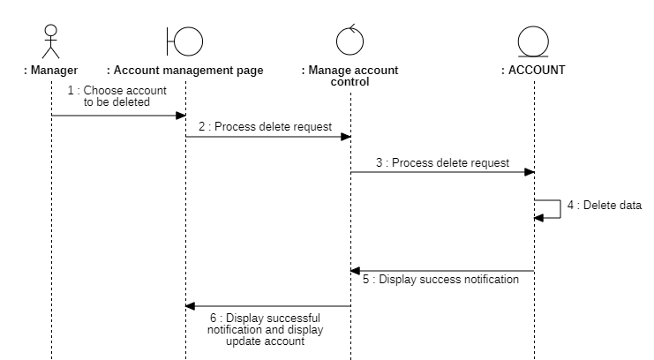 Figure 3.36: Delete account - Sequence diagram

#### Class diagram:

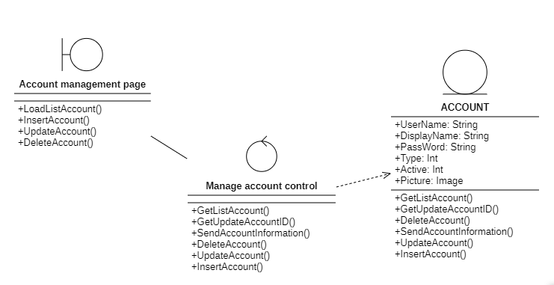 Figure 3.37: Manage account - Class diagram

### Manage surcharges:

#### Sequence diagram:

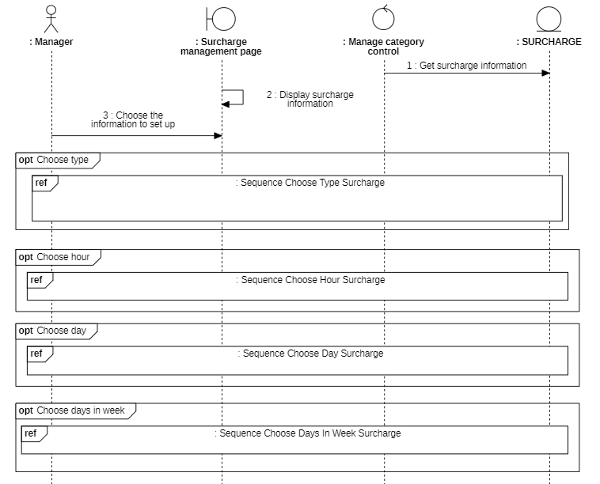 Figure 3.38: Manage surcharges - Sequence diagram

1. Choose type

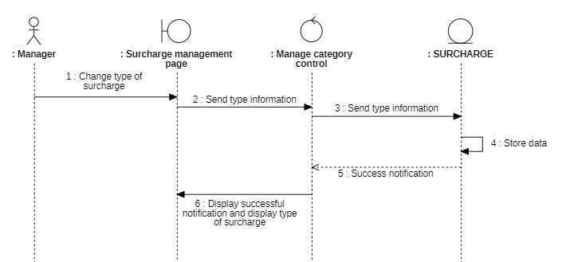 Figure 3.39: Choose type surcharges - Sequence diagram

1. Choose hour

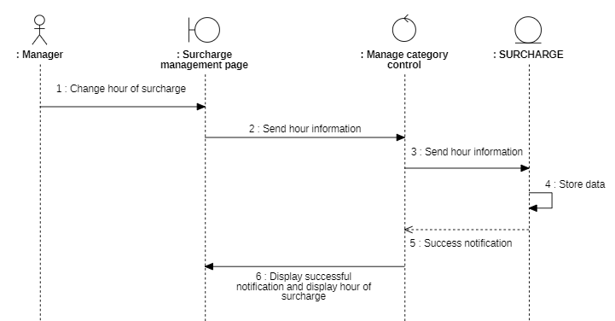 Figure 3.40: Choose hour surcharges - Sequence diagram

1. Choose day 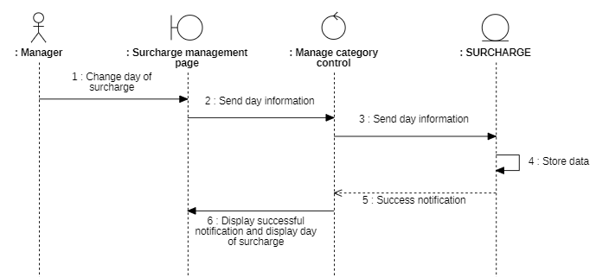

Figure 3.41: Choose day surcharges - Sequence diagram

1. Choose days in week

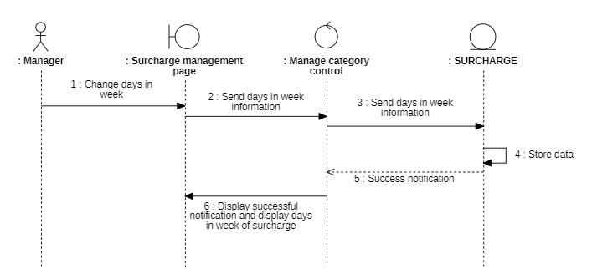 Figure 3.42: Choose days in week - Sequence diagram

#### Class diagram:

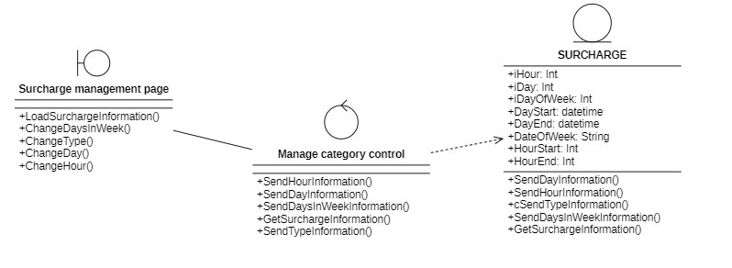 Figure 3.43: Manage surcharges - Class diagram

### Manage categories:

#### Sequence diagram:

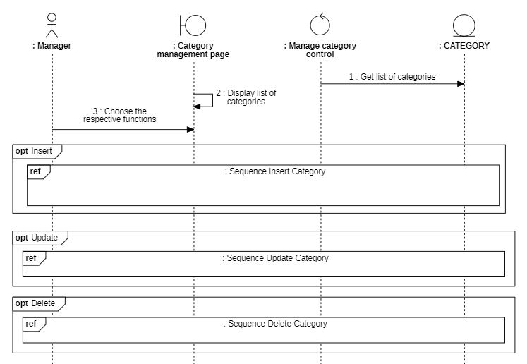 Figure 3.44: Manage categories - Sequence diagram

1. Insert

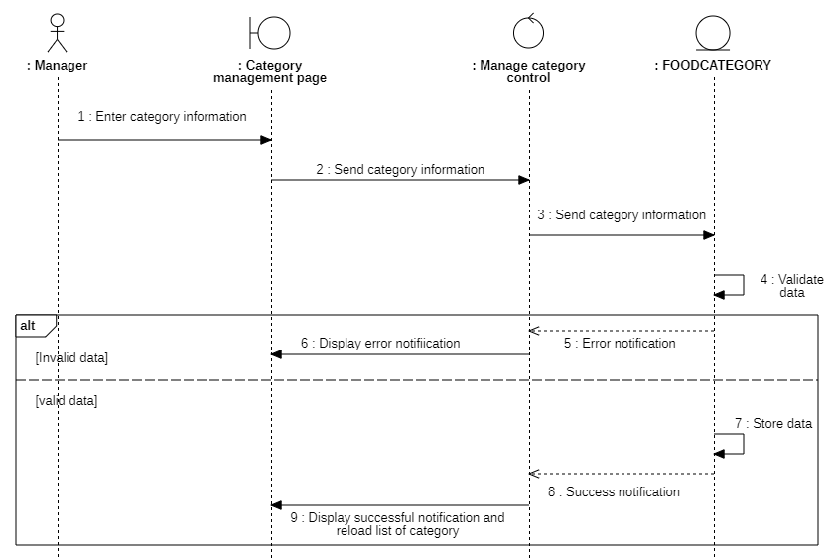 Figure 3.45: Insert category - Sequence diagram

1. Update

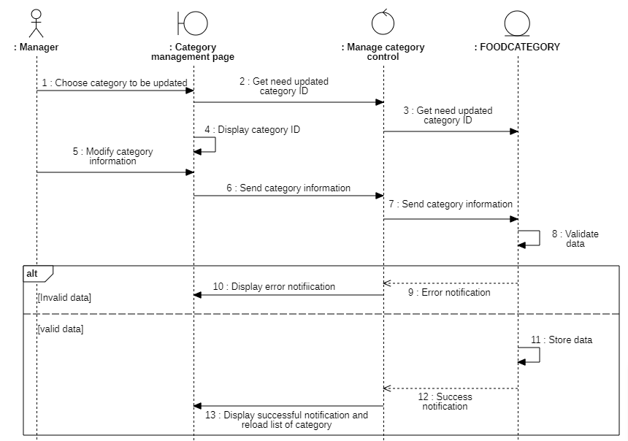 Figure 3.46: Update category - Sequence diagram

1. Delete

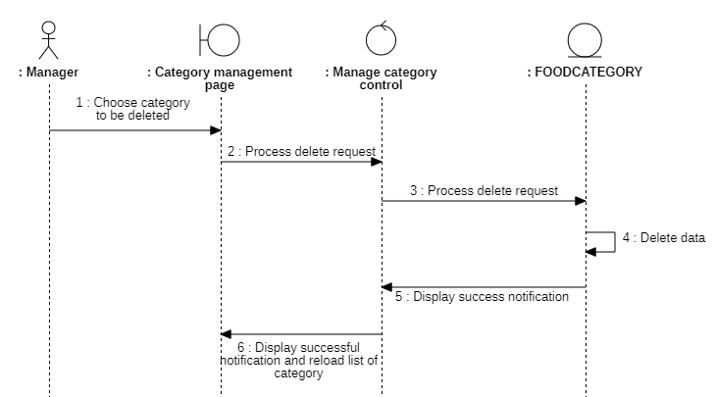 Figure 3.47: Delete category - Sequence diagram

#### Class diagram:

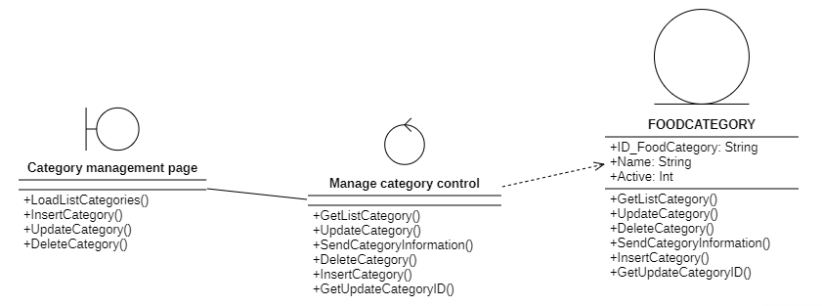 Figure 3.48: Manage categories - Class diagram

### Manage table:

#### Sequence diagram:

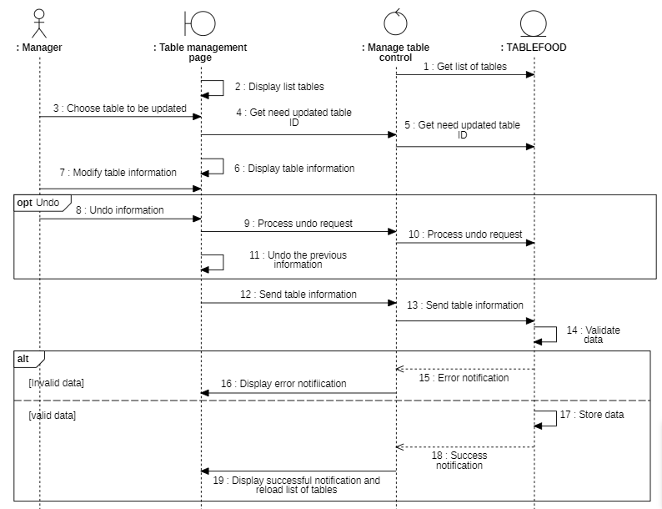 Figure 3.49: Manage table - Sequence diagram

#### Class diagram:

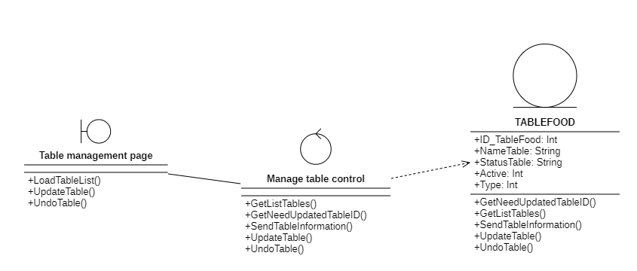 Figure 3.50: Manage table - Class diagram

### Manage discount codes:

#### Sequence diagram:

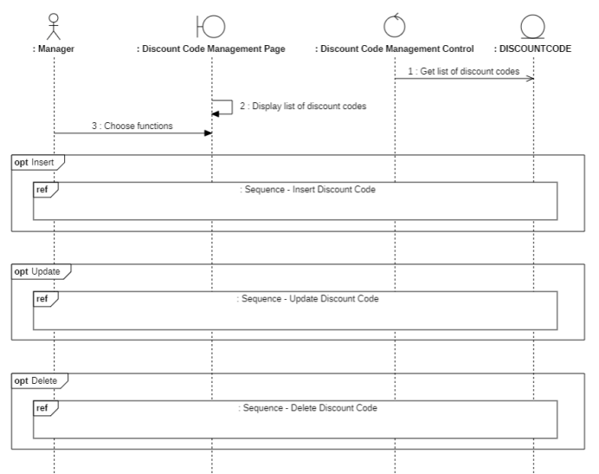

Figure 3.51: Manage discount codes - Sequence diagram

1. Insert

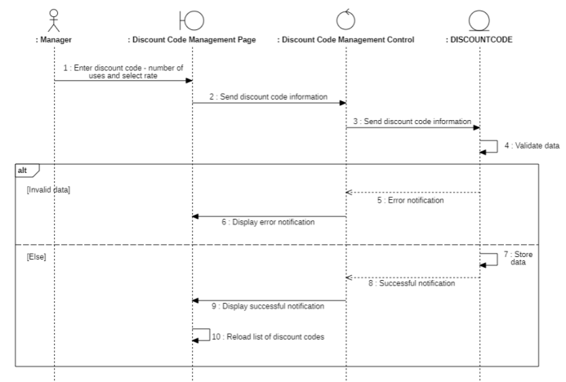

Figure 3.52: Insert discount code - Sequence diagram

1. Update

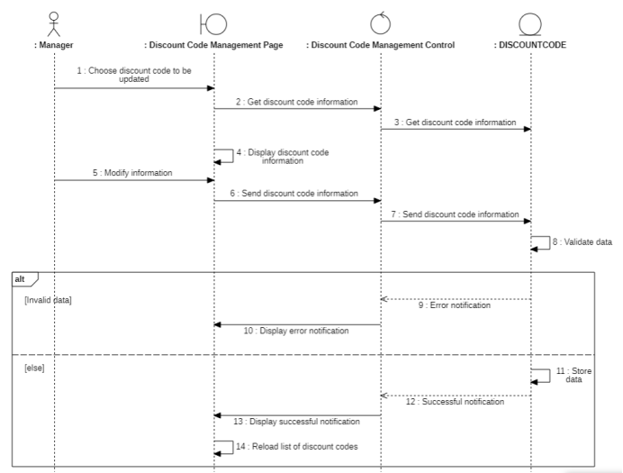

Figure 3.53: Update discount code - Sequence diagram

1. Delete

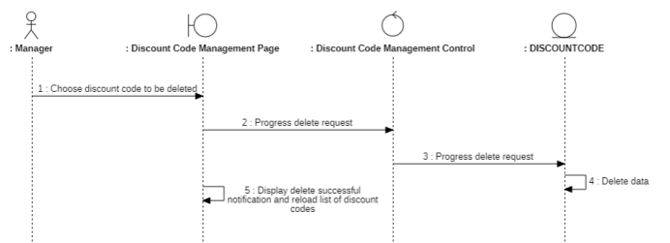

Figure 3.54: Delete discount code - Sequence diagram

#### Class diagram:

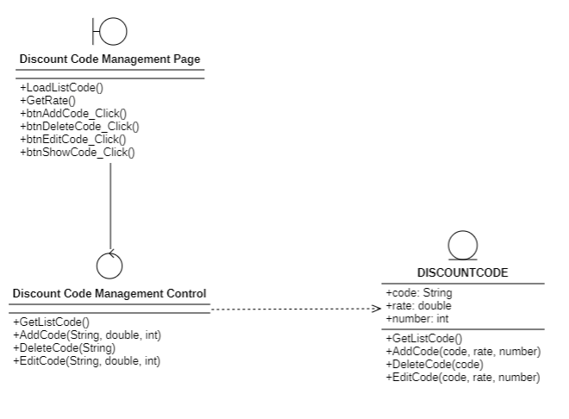

Figure 3.55: Manage discount codes - Class diagram

### Manage food and drink:

#### Sequence diagram:

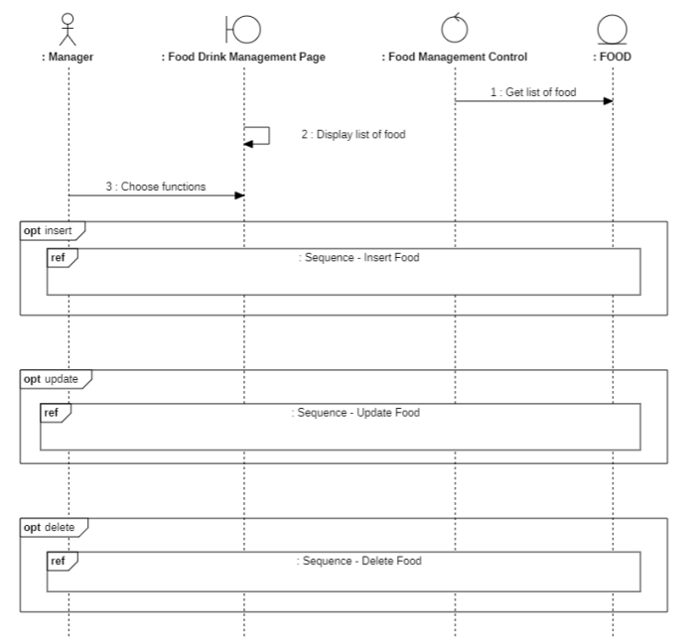

Figure 3.56: Manage food and drink - Sequence diagram

1. Insert

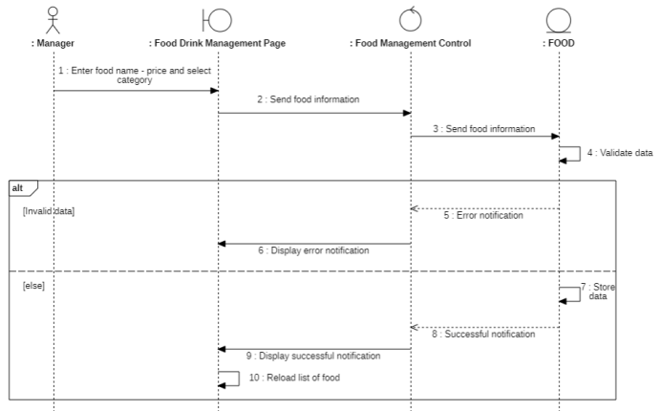

Figure 3.57: Insert food - Sequence diagram

1. Update

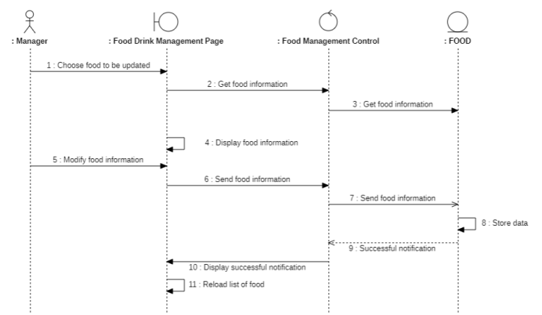

Figure 3.58: Update food - Sequence diagram

1. Delete

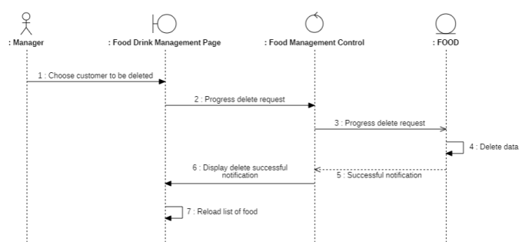

Figure 3.59: Delete food - Sequence diagram

#### Class diagram:

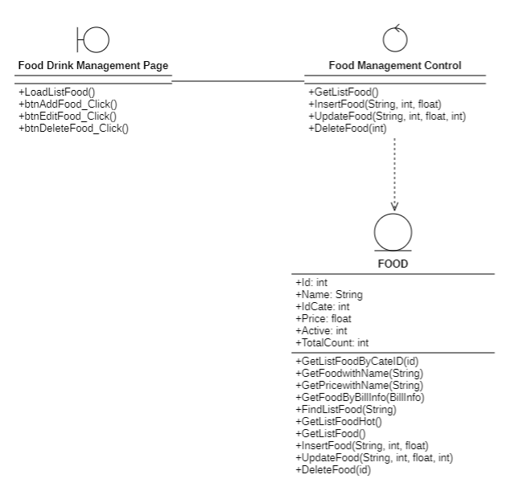

Figure 3.60: Manage food and drink - Class diagram

### Revenue statistics:

#### Sequence diagram:

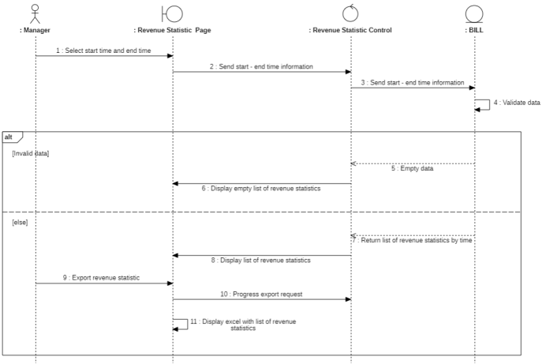

Figure 3.61: Revenue statistics - Sequence diagram

#### Class diagram:

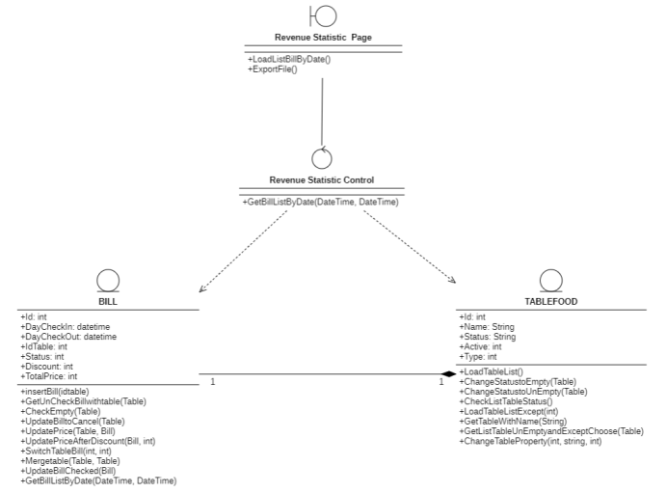

Figure 3.62: Revenue statistics - Class diagram

### Manage shop information:

#### Sequence diagram:

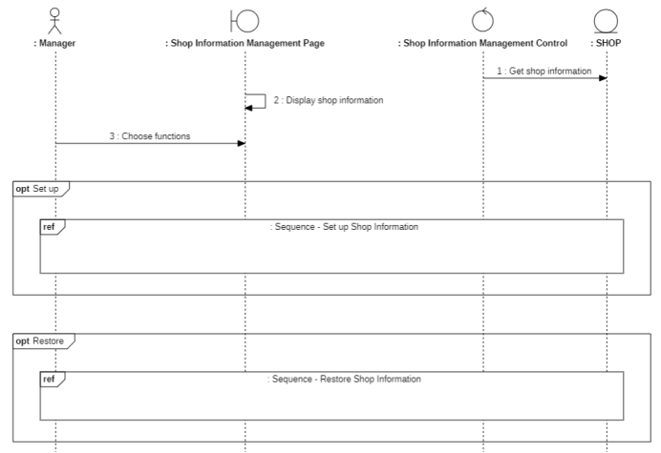

Figure 3.63: Manage shop information - Sequence diagram

1. Set up

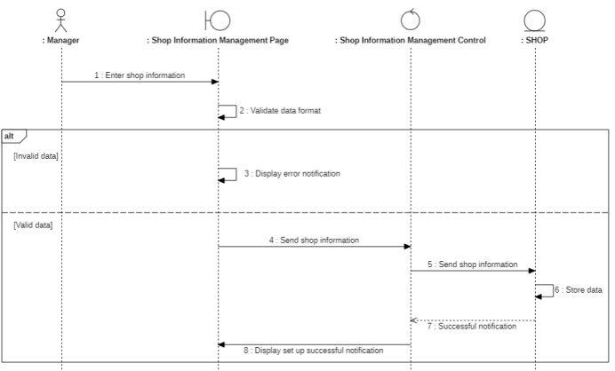

Figure 3.64: Set up shop information - Sequence diagram

1. Restore

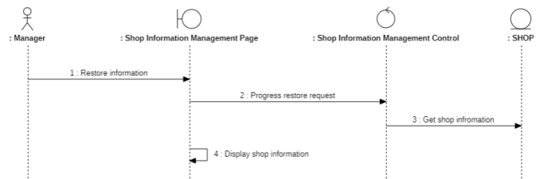

Figure 3.65: Restore shop information - Sequence diagram

#### Class diagram:

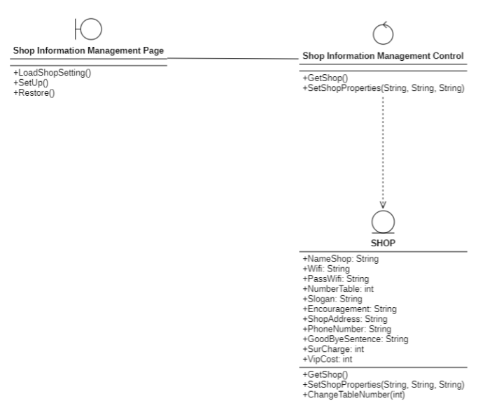

Figure 3.66: Manage shop information - Class diagram

## Class Diagram and Entity class diagram:

### Employee overview class diagram

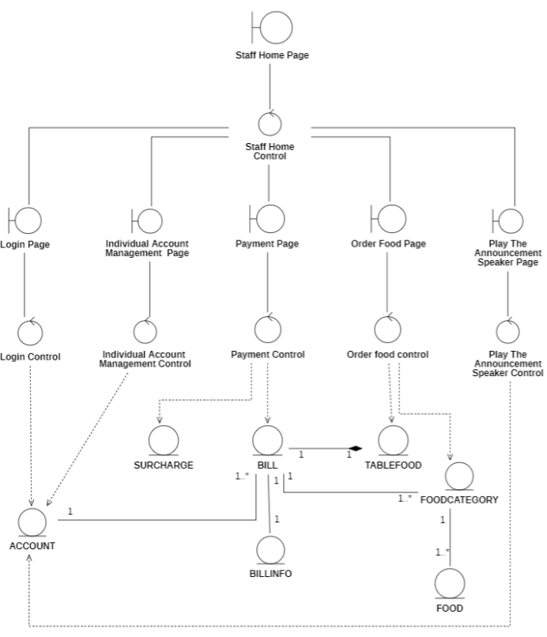

Figure 3.67: Employee overview - Class diagram

### Manager overview class diagram

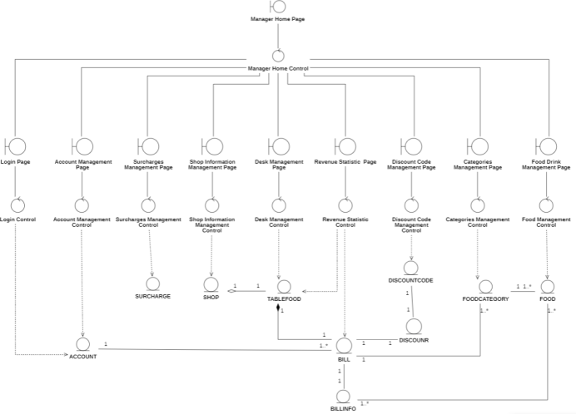

Figure 3.68: Manager overview - Class diagram

### Entity class diagram

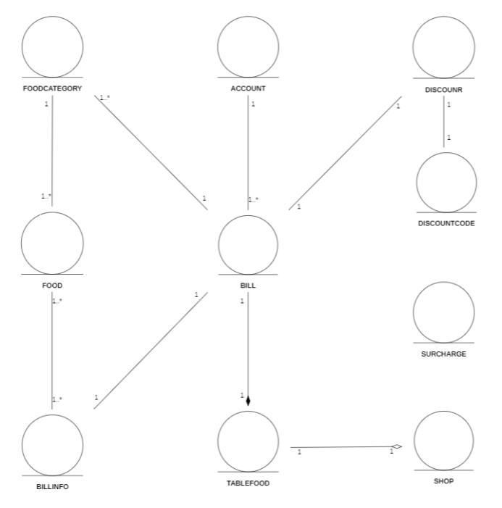

Figure 3.69: Entity - Class diagram

### Class diagram Specification

#### Account

Table 3.17: Account - Class diagram specification

|  |  |  |
| --- | --- | --- |
| Account | | |
| Attribute | Variable | Meaning |
| UserName: nvarchar(100) | A unique identifier for the user or account in the system. |
| DisplayName: nvarchar(100) | The name of the user or account as it should be displayed. |
| PassWord: nvarchar(1000) | A secret string of characters used for authentication. |
| Type: int | A category or classification of the user or account. |
| Active: int | Indicates whether the user or account is currently active. |
| Picture: image | An image associated with the user or account. |
| Operation | Function | Meaning |
| hashPass(password): string | Hashes a password string using a secure hash algorithm. |
| Login(userName, passWord): bool | Authenticates a user by verifying their username and password. |
| LoadUser(UserName): Account or null | Retrieves the user data from the database. |
| ChangeDisplayName(acc, newDisplayName): void | Updates the display name of a user in the database. |
| GetListAccount(): DataTable | Retrieves a list of user accounts from the database. |
| InsertAccount(name, displayname, type): bool | Inserts a new user account into the database. |
| UpdateAccount(name, displayName, type): bool | Updates an existing user account in the database. |
| DeleteAccount(name): bool | Deletes a user account from the database. |
| ResetPassword(name): bool | Resets the password of a user account. |
| UpdateAccountProfile(userName, displayName, pass, newpass): bool | Updates the profile information of a user account. |
| hashPass(password): string | Hash the password. |

#### Bill

Table 3.18: Bill - Class diagram specification

|  |  |  |
| --- | --- | --- |
| Bill | | |
| Attribute | Variable | Meaning |
| ID_Bill: int | The unique identifier of the bill. |
| DateCheckIn: datetime | The date and time when the customer checked in to the table. |
| DateCheckOut: date | The date and time when the customer checked out from the table. |
| ID_TableFood: int | The unique identifier of the table where the customer was seated. |
| status: int | The status of the bill, such as "paid" or "unpaid". |
| totalPrice: int | The total price of the bill. |
| discount: int | The discount applied to the bill, if any. |
| ID_User: nvarchar(100) | The unique identifier of the user who created the bill. |
| Attribute | Function | Meaning |
| insertBill(idtable): void | Inserts a new bill into the database for a specified table. |
| GetUnCheckBillwithtable(table): Bill or null | Retrieves an unchecked bill for a specified table from the database. |
| CheckEmpty(table): boolean | Checks if a specified table has an empty bill (status='0') in the database. |
| UpdateBilltoCancel(table): void | Updates the status of an unchecked bill for the specified table to '2' (cancelled) in the database. |
| UpdatePrice(table, bill): void | Calculates and updates the total price of a specified bill for a specified table in the database. |
| UpdatePriceAfterDiscount(bill, money): void | Updates the total price of a specified bill in the database after a discount has been applied. |
| SwitchTableBill(idTable1, idTable2): void | Switches the bills of two specified tables in the database. |
| Mergetable(table1, table2): void | Merges the bills of two specified tables in the database and updates the bill information accordingly. |
| UpdateBillChecked(bill): void | Updates the status of a specified bill to '1' (checked) in the database. |
| GetBillListByDate(checkIn, checkOut): DataTable | Retrieves a list of bills from the database for a specified time range. |

#### BillInfo

Table 3.19: BillInfo - Class diagram specification

|  |  |  |
| --- | --- | --- |
| BillInfo | | |
| Attribute | Variable | Meaning |
|  | ID_BillInfo: int | unique identifier for a specific item on a bill |
|  | ID_Bill: int | foreign key that links a specific item on a bill to the bill itself |
|  | ID_Food: int | foreign key that links a specific item on a bill to the food item being ordered |
|  | count: int | quantity of a specific food item that has been ordered and is being added to the bill |
| Operation | Function | Meaning |
|  | InsertBillInfo(billId, foodId, count): void | Inserts a new item into the database for a specified bill and food item, with a given quantity |
|  | GetListBillInfoWithTable(table): list[BillInfo] or null | Retrieves a list of BillInfo objects associated with a specified Table object from the database |
|  | UpdateBillInfoifOrderSameFood(count, table, idFood): void | Updates the quantity of a specified food item on a specified table's bill in the database |
|  | GetBillInfowithTableIDandFoodID(idFood, table): BillInfo or null | Retrieves a BillInfo object from the database for a specified food item and table |
|  | DeleteCountequal0(table): void | Deletes any BillInfo objects associated with a specified Table object in the database that have a quantity of 0 |

#### Discount

Table 3.20: Discount - Class diagram specification

|  |  |  |
| --- | --- | --- |
| Discount | | |
| Attribute | Variable | Meaning |
|  | Rate: float | the percentage discount applied to a product or service |
|  | Money: int | the amount of money that is discounted from the original price. |
| Operation | Function | Meaning |
|  | LoadRateMoney(rate): int | Calculates the monetary value of a discount rate provided as a string input |
|  | CreateRandCode(): string | Generates a random code |
|  | GetDiscount(money): double | Calculates the discount value based on a given monetary value |
|  | CreateCode(rate): string | Generates a code based on a given discount rate |
|  | GetRate(code): double | Calculates the discount rate based on a given code |
|  | SetDiscount(Rate,money): bool | Sets a discount based on a provided discount rate and monetary value |

#### DiscountCode

Table 3.21: DiscountCode - Class diagram specification

|  |  |  |
| --- | --- | --- |
| DiscountCode | | |
| Attribute | Variable | Meaning |
|  | Code: nvarchar(10) | represent a code or identifier. |
|  | Rate: float | represent a discount rate. |
|  | DayTake: smalldatetime | stores the date and time with a precision of one minute. |
|  | Number: int | represent a quantity or count. |
| Operation | Function | Meaning |
|  | GetListCode(): List<DiscountCode> | retrieves a list of discount codes |
|  | AddCode(code, rate, number): bool | adds a new discount code to the system with the provided code, discount rate, and number of uses |
|  | DeleteCode(code): bool | deletes a discount code from the system with the provided code |
|  | EditCode(code, rate, number): bool | updates the discount rate and number of uses for a discount code with the provided code |
|  | UpdateCode(code): void | updates the usage information for a discount code with the provided code |

#### Food

Table 3.22: Food - Class diagram specification

|  |  |  |
| --- | --- | --- |
| Food | | |
| Attribute | Variable | Meaning |
|  | ID_Food: int | the unique identifier for a food item in the table |
|  | NameFood: nvarchar(100) | the name of a food item |
|  | ID_FoodCategory: int | the category of a food item |
|  | Price: float | the price of a food item |
|  | Active: int | the status of a food item |
|  | TotalCount: int | the total count or quantity of a food item in inventory |
| Operation | Function | Meaning |
|  | GetListFoodByCateID( id) | Retrieves a list of food items from the database that belong to a particular category, identified by the provided ID. |
|  | GetFoodwithName( name) | Retrieves a food item from the database with the provided name. |
|  | GetPricewithName( name) | Retrieves the price of a food item from the database with the provided name. |
|  | GetFoodByBillInfo( billInfo) | Retrieves a food item from the database based on the provided BillInfo object. |
|  | FindListFood( name) | Searches for food items in the database based on the provided search term. |
|  | IncreaseFoodTotalCount( billInfo) | Increases the total count of a food item in the database based on the provided BillInfo object. |
|  | GetListFoodHot() | Retrieves a list of hot or popular food items from the database. |
|  | InsertFood( name, categoryid, price) | Inserts a new food item into the database with the provided name, category ID, and price. |
|  | UpdateFood( name, categoryid, price, id) | Updates an existing food item in the database with the provided name, category ID, price, and ID. |
|  | DeleteFood( id) | Deletes a food item from the database with the provided ID. |
|  | GetListFood() | Retrieves a list of all food items from the database and returns it as a DataTable object. |

#### FoodCategory

Table 3.23: FoodCategory - Class diagram specification

|  |  |  |
| --- | --- | --- |
| FoodCategory | | |
| Attribute | Variable | Meaning |
|  | ID_FoodCategory: int | An integer identifier for a food category. |
|  | name: nvarchar(100) | A string containing the name of a food category, with a maximum length of 100 characters. |
|  | Active: int | An integer representing whether a food category is active (1) or inactive (0) in the database. |
| Operation | Function | Meaning |
|  | GetListCategory(): List<Category> | Retrieves a list of all categories from the database |
|  | GetIdCateWithName(name): int | Retrieves the ID of a category with a specified name from the database |
|  | GetFirstCate(): Category | Retrieves the first category from the database |
|  | GetCateWithFood(food): Category or null | Retrieves the category that a specified food item belongs to from the database |
|  | InsertCategory(name): bool | Inserts a new category with a specified name into the database |
|  | UpdateCategory(name, id): bool | Updates the name of a category with a specified ID in the database |
|  | DeleteCategory(id): bool | Deletes a category with a specified ID from the database |

#### Shop

Table 3.24: Shop - Class diagram specification

|  |  |  |
| --- | --- | --- |
| Shop | | |
| Attribute | Variable | Meaning |
|  | NameShop: nvarchar(100) | The name of the shop. |
|  | Wifi: nvarchar(100) | The name of the Wi-Fi network provided by the shop. |
|  | PassWifi: nvarchar(100) | The password for the Wi-Fi network. |
|  | NumberTable: int | The total number of tables available in the shop. |
|  | Slogan: nvarchar(100) | The slogan or tagline of the shop. |
|  | Encouragement: nvarchar(100) | Any promotional message or encouragement for customers, such as a discount. |
|  | ShopAddress: nvarchar(100) | The physical address of the shop. |
|  | PhoneNumber: varchar(10) | The phone number of the shop. |
|  | GoodByeSentence: nvarchar(100) | A farewell message for customers, such as "Thank you for visiting!". |
|  | SurCharge: int | Any surcharge or additional fee applied to orders. |
|  | VipCost: int | The cost of a VIP membership, if offered by the shop. |
| Operation | Function | Meaning |
|  | GetShop(): Shop | Returns the details of the shop as a Shop object. |
|  | SetShopProperties(nameShop, wifi, passwifi, numberTable, slogan, encouragement, shopAddress, phoneNumber, goodByeSentence, surcharge, vipCost): bool | Sets the properties of the shop, including its name, Wi-Fi information, table count, slogan, address, phone number, farewell message, surcharge, and VIP cost. |
|  | ChangeTableNumber(numberTable): void | Changes the number of tables in the shop to the specified value. |

#### SurCharge

Table 3.25: SurCharge - Class diagram specification

|  |  |  |
| --- | --- | --- |
| SurCharge | | |
| Attribute | Variable | Meaning |
| iHour: int | the hour of the day (0-23) when a surcharge applies. |
| iDay: int | the day of the month (1-31) when a surcharge applies. |
| iDayofWeek: int | the day of the week (1-7, where 1 is Sunday and 7 is Saturday) |
| HourStart: int | the starting hour (0-23) of a time range during which a surcharge applies. |
| HourEnd: int | the ending hour (0-23) of a time range during which a surcharge applies. |
| DayStart: datetime | the starting date and time of a time range during which a surcharge applies. |
| DayEnd: datetime | the ending date and time of a time range during which a surcharge applies. |
| DateofWeek: varchar(7) | the day of the week (e.g. "Monday", "Tuesday", etc.) when a surcharge applies. |
| Operation | Function | Meaning |
| GetSurcharge(): Surcharge | returns a surcharge |
| ChangeChoose(choose): bool | hanges the "choose" value to a new value |
| ChangeHour(timeStart,timeEnd): bool | changes the start and end times for a given hour |
| ChangeDay(timeStart,timeEnd): bool | changes the start and end times for a given day |
| ChangeDateofWeek(dateofweek): bool | hanges the "dateofweek" value to a new value |

#### TableFood

Table 3.26: TableFood - Class diagram specification

|  |  |  |
| --- | --- | --- |
| TableFood | | |
| Attribute | Variable | Meaning |
| ID_TableFood: int | a unique identifier for a table |
| NameTable: nvarchar(100) | the name or identifier of the table |
| StatusTable: nvarchar(100) | the current status of the table |
| Active: int | represents whether or not the table is currently active and available for use |
| Type: int | the type of table |
| Operation | Function | Meaning |
| LoadTableList(): List<Table> | loads a list of all tables from a data source |
| ChangeStatustoEmpty(Table table): void | changes the status of a given table to "empty" and updates it in the data source. |
| ChangeStatustoUnEmpty(Table table): void | changes the status of a given table to "unempty" |
| LoadTableListExcept(int idTable): List<Table> | loads a list of all tables from a data source |
| GetTableWithName(string nameTable): Table | retrieves a Table object with the given nameTable from the data source |
| GetListTableUnEmptyandExceptChoose(Table table): List<Table> | retrieves a list of all tables from the data source that are currently occupied |
| ChangeTableProperty(int type,string Name,int ID): bool | changes one or more properties of a table with the given ID in the data source |

#### Manage Account Controller

Table 3.27: Manage Account Controller - Class diagram specification

|  |  |  |
| --- | --- | --- |
| Manage Account Controller | | |
| Operation | Function | Meaning |
|  | hashPass(password): string | Hashes a password string using a secure hash algorithm. |
|  | Login(userName, passWord): bool | Authenticates a user by verifying their username and password. |
|  | LoadUser(UserName): Account or null | Retrieves the user data from the database. |
|  | ChangeDisplayName(acc, newDisplayName): void | Updates the display name of a user in the database. |
|  | GetListAccount(): DataTable | Retrieves a list of user accounts from the database. |
|  | InsertAccount(name, displayname, type): bool | Inserts a new user account into the database. |
|  | UpdateAccount(name, displayName, type): bool | Updates an existing user account in the database. |
|  | DeleteAccount(name): bool | Deletes a user account from the database. |
|  | ResetPassword(name): bool | Resets the password of a user account. |
|  | UpdateAccountProfile(userName, displayName, pass, newpass): bool | Updates the profile information of a user account. |
|  | hashPass(password): string | Hash the password. |

#### Manage Bill Controller

Table 3.28: Manage Bill Controller - Class diagram specification

|  |  |  |
| --- | --- | --- |
| Manage Bill Controller | | |
| Attribute | Function | Meaning |
|  | insertBill(idtable): void | Inserts a new bill into the database for a specified table. |
|  | GetUnCheckBillwithtable(table): Bill or null | Retrieves an unchecked bill for a specified table from the database. |
|  | CheckEmpty(table): boolean | Checks if a specified table has an empty bill (status='0') in the database. |
|  | UpdateBilltoCancel(table): void | Updates the status of an unchecked bill for the specified table to '2' (cancelled) in the database. |
|  | UpdatePrice(table, bill): void | Calculates and updates the total price of a specified bill for a specified table in the database. |
|  | UpdatePriceAfterDiscount(bill, money): void | Updates the total price of a specified bill in the database after a discount has been applied. |
|  | SwitchTableBill(idTable1, idTable2): void | Switches the bills of two specified tables in the database. |
|  | Mergetable(table1, table2): void | Merges the bills of two specified tables in the database and updates the bill information accordingly. |
|  | UpdateBillChecked(bill): void | Updates the status of a specified bill to '1' (checked) in the database. |
|  | GetBillListByDate(checkIn, checkOut): DataTable | Retrieves a list of bills from the database for a specified time range. |

#### Manage BillInfo Controller

Table 3.29: Manage BillInfo Controller - Class diagram specification

|  |  |  |
| --- | --- | --- |
| Manage BillInfo Controller | | |
| Operation | Function | Meaning |
|  | InsertBillInfo(billId, foodId, count): void | Inserts a new item into the database for a specified bill and food item, with a given quantity |
|  | GetListBillInfoWithTable(table): list[BillInfo] or null | Retrieves a list of BillInfo objects associated with a specified Table object from the database |
|  | UpdateBillInfoifOrderSameFood(count, table, idFood): void | Updates the quantity of a specified food item on a specified table's bill in the database |
|  | GetBillInfowithTableIDandFoodID(idFood, table): BillInfo or null | Retrieves a BillInfo object from the database for a specified food item and table |
|  | DeleteCountequal0(table): void | Deletes any BillInfo objects associated with a specified Table object in the database that have a quantity of 0 |

#### Manage Discount Controller

Table 3.30: Manage Discount Controller - Class diagram specification

|  |  |  |
| --- | --- | --- |
| Manage Discount Controller | | |
| Operation | Function | Meaning |
|  | LoadRateMoney(rate): int | Calculates the monetary value of a discount rate provided as a string input |
|  | CreateRandCode(): string | Generates a random code |
|  | GetDiscount(money): double | Calculates the discount value based on a given monetary value |
|  | CreateCode(rate): string | Generates a code based on a given discount rate |
|  | GetRate(code): double | Calculates the discount rate based on a given code |
|  | SetDiscount(Rate,money): bool | Sets a discount based on a provided discount rate and monetary value |

#### Manage DiscountCode Controller

Table 3.31: Manage DiscountCode Controller - Class diagram specification

|  |  |  |
| --- | --- | --- |
| Manage DiscountCode Controller | | |
| Operation | Function | Meaning |
|  | GetListCode(): List<DiscountCode> | retrieves a list of discount codes |
|  | AddCode(code, rate, number): bool | adds a new discount code to the system with the provided code, discount rate, and number of uses |
|  | DeleteCode(code): bool | deletes a discount code from the system with the provided code |
|  | EditCode(code, rate, number): bool | updates the discount rate and number of uses for a discount code with the provided code |
|  | UpdateCode(code): void | updates the usage information for a discount code with the provided code |

#### Manage food control

Table 3.32: Manage food control - Class diagram specification

|  |  |  |
| --- | --- | --- |
| Manage food control | | |
| Operation | Function | Meaning |
|  | GetListFoodByCateID( id) | Retrieves a list of food items from the database that belong to a particular category, identified by the provided ID. |
|  | GetFoodwithName( name) | Retrieves a food item from the database with the provided name. |
|  | GetPricewithName( name) | Retrieves the price of a food item from the database with the provided name. |
|  | GetFoodByBillInfo( billInfo) | Retrieves a food item from the database based on the provided BillInfo object. |
|  | FindListFood( name) | Searches for food items in the database based on the provided search term. |
|  | IncreaseFoodTotalCount( billInfo) | Increases the total count of a food item in the database based on the provided BillInfo object. |
|  | GetListFoodHot() | Retrieves a list of hot or popular food items from the database. |
|  | InsertFood( name, categoryid, price) | Inserts a new food item into the database with the provided name, category ID, and price. |
|  | UpdateFood( name, categoryid, price, id) | Updates an existing food item in the database with the provided name, category ID, price, and ID. |
|  | DeleteFood( id) | Deletes a food item from the database with the provided ID. |
|  | GetListFood() | Retrieves a list of all food items from the database and returns it as a DataTable object. |

#### Manage category control

Table 3.33: Manage category control - Class diagram specification

|  |  |  |
| --- | --- | --- |
| Manage category control | | |
| Operation | Function | Meaning |
|  | GetListCategory(): List<Category> | Retrieves a list of all categories from the database |
|  | GetIdCateWithName(name): int | Retrieves the ID of a category with a specified name from the database |
|  | GetFirstCate(): Category | Retrieves the first category from the database |
|  | GetCateWithFood(food): Category or null | Retrieves the category that a specified food item belongs to from the database |
|  | InsertCategory(name): bool | Inserts a new category with a specified name into the database |
|  | UpdateCategory(name, id): bool | Updates the name of a category with a specified ID in the database |
|  | DeleteCategory(id): bool | Deletes a category with a specified ID from the database |

#### Manage shop control

Table 3.34: Manage shop control - Class diagram specification

|  |  |  |
| --- | --- | --- |
| Manage shop control | | |
| Operation | Function | Meaning |
|  | GetShop(): Shop | Returns the details of the shop as a Shop object. |
|  | SetShopProperties(nameShop, wifi, passwifi, numberTable, slogan, encouragement, shopAddress, phoneNumber, goodByeSentence, surcharge, vipCost): bool | Sets the properties of the shop, including its name, Wi-Fi information, table count, slogan, address, phone number, farewell message, surcharge, and VIP cost. |
|  | ChangeTableNumber(numberTable): void | Changes the number of tables in the shop to the specified value. |

#### Manage surcharge control

Table 3.35: Manage surcharge control - Class diagram specification

|  |  |  |
| --- | --- | --- |
| Manage surcharge control | | |
| Operation | Function | Meaning |
| GetSurcharge(): Surcharge | returns a surcharge |
| ChangeChoose(choose): bool | hanges the "choose" value to a new value |
| ChangeHour(timeStart,timeEnd): bool | changes the start and end times for a given hour |
| ChangeDay(timeStart,timeEnd): bool | changes the start and end times for a given day |
| ChangeDateofWeek(dateofweek): bool | hanges the "dateofweek" value to a new value |

#### Manage table control

Table 3.36: Manage table control - Class diagram specification

|  |  |  |
| --- | --- | --- |
| Manage table control | | |
| Operation | Function | Meaning |
| LoadTableList(): List<Table> | loads a list of all tables from a data source |
| ChangeStatustoEmpty(Table table): void | changes the status of a given table to "empty" and updates it in the data source. |
| ChangeStatustoUnEmpty(Table table): void | changes the status of a given table to "unempty" |
| LoadTableListExcept(int idTable): List<Table> | loads a list of all tables from a data source |
| GetTableWithName(string nameTable): Table | retrieves a Table object with the given nameTable from the data source |
| GetListTableUnEmptyandExceptChoose(Table table): List<Table> | retrieves a list of all tables from the data source that are currently occupied |
| ChangeTableProperty(int type,string Name,int ID): bool | changes one or more properties of a table with the given ID in the data source |

## State diagram

### Table

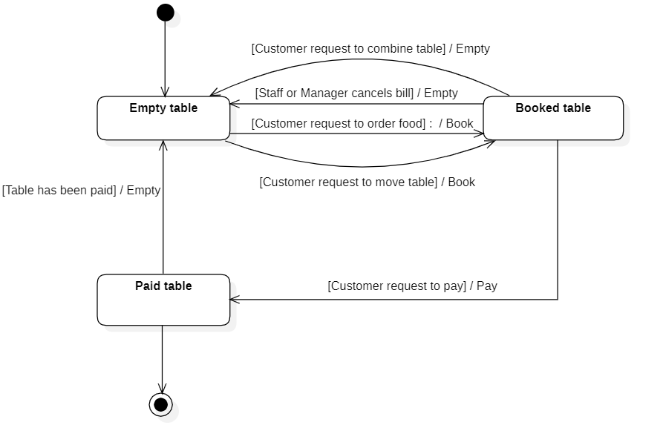

Figure 3.70: Table - State diagram

### Discount code

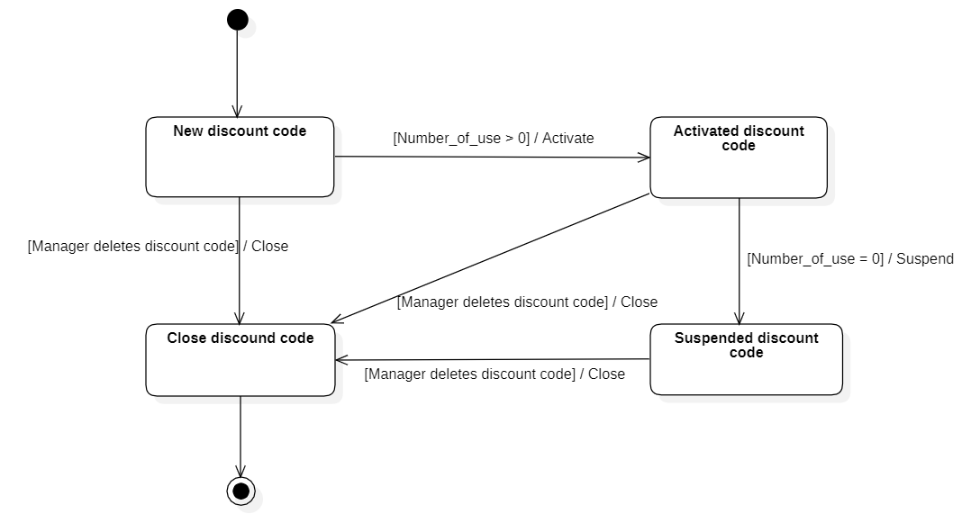

Figure 3.71: Discount code - State diagram

### Bill

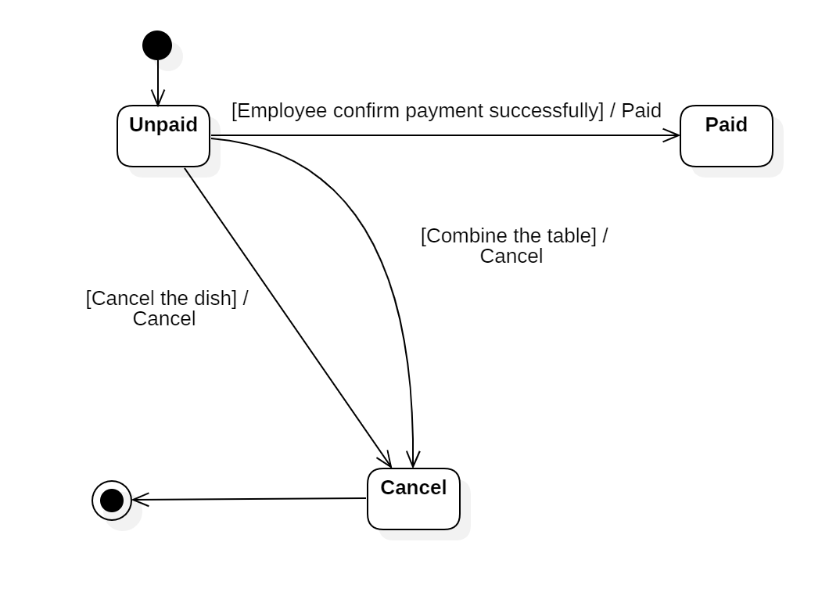Figure 3.72: Bill - State diagram

## Mapping to Relational Model from Entity class diagram:

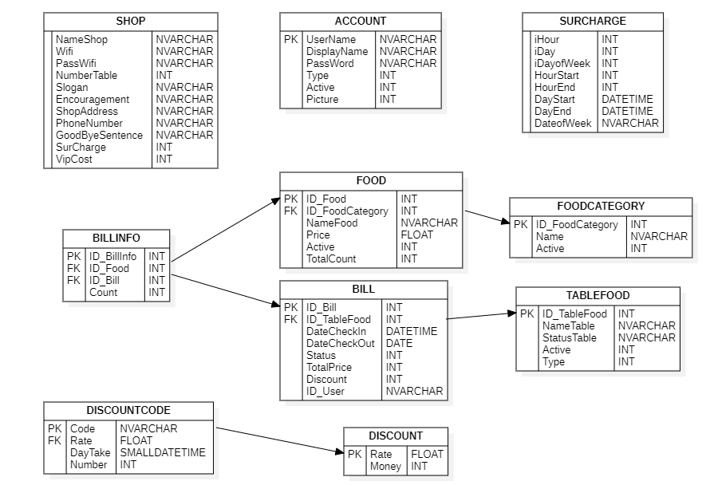 Figure 3.73: Mapping to Relational Model from Entity - Class diagram

# IMPLEMENTATION AND TESTING

## Introduction to the implementation environment

* Operating system: Window 10, 11
* Database: Microsoft SQL Server
* Text Editor: Visual Studio
* Program Language: C#

## User Interface

### Employee Interface

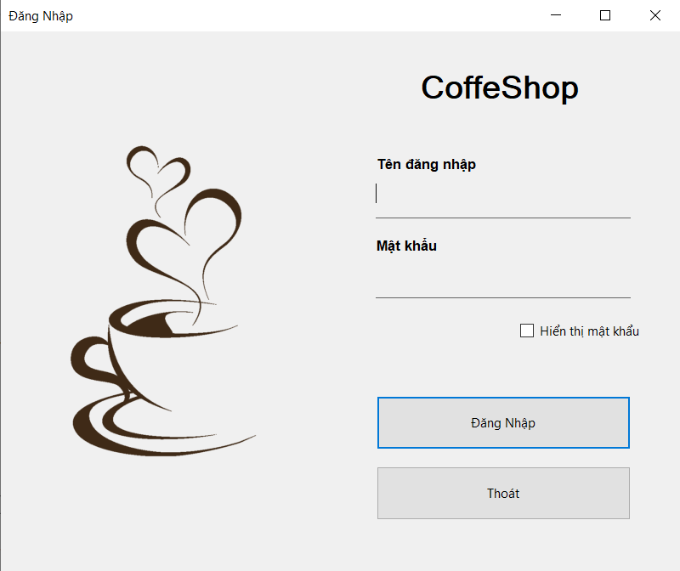

Figure 4.1: Login page

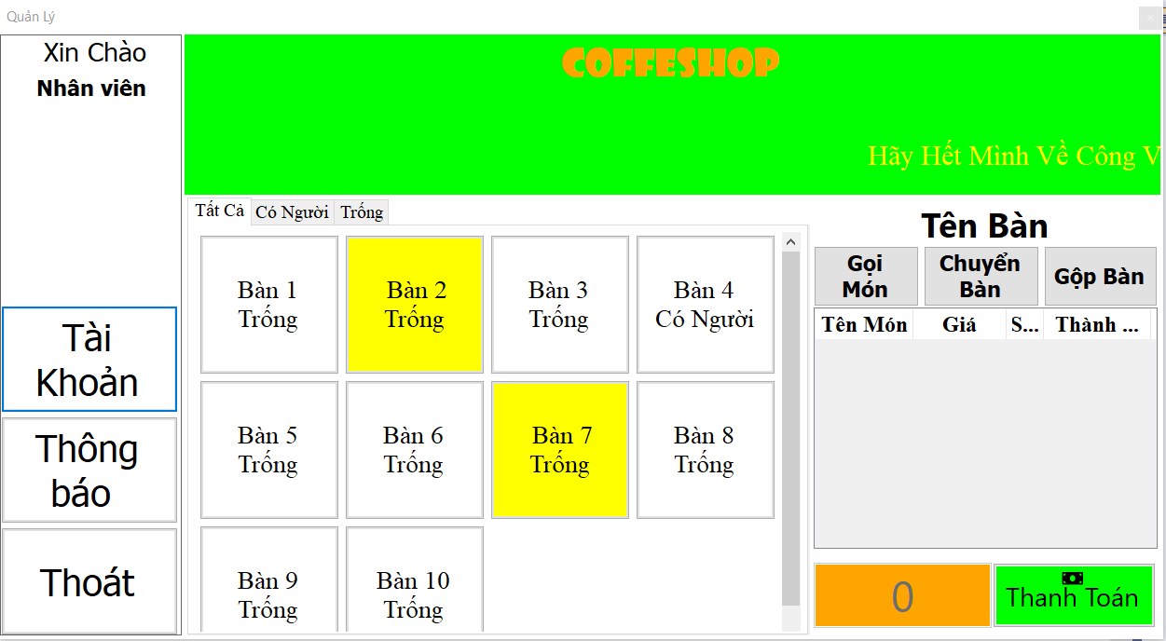

Figure 4.2: Staff Home page

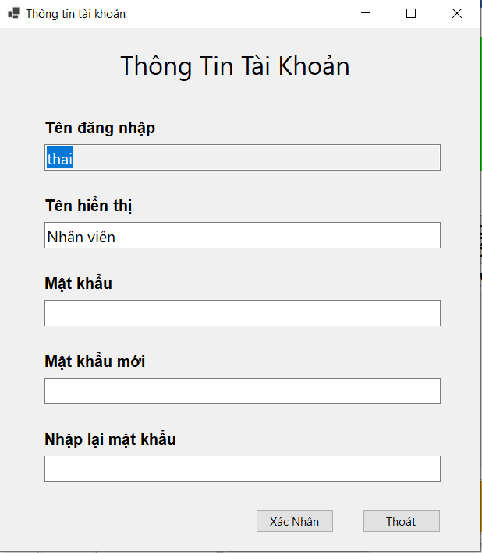

Figure 4.3: Information page

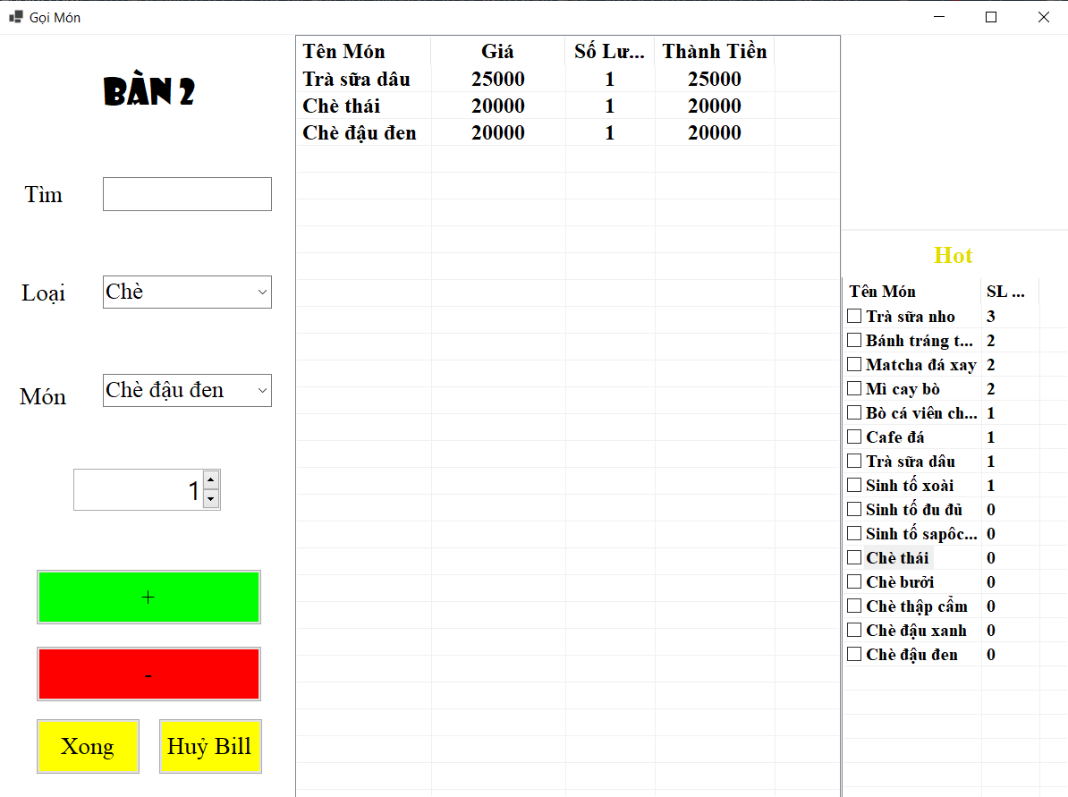

Figure 4.4: Order food

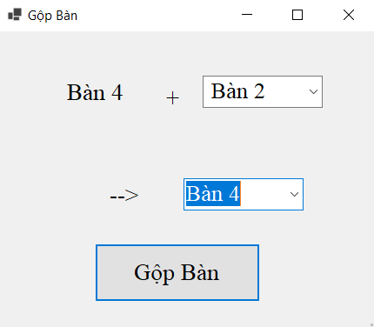

Figure 4.5: Combine table

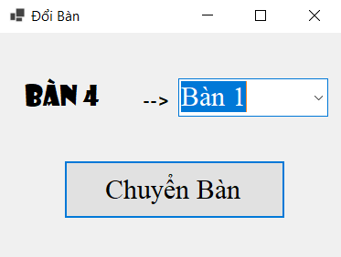

Figure 4.6: Transfer table

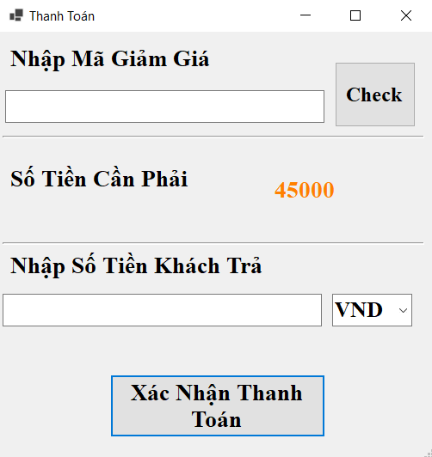

Figure 4.7: Payment page

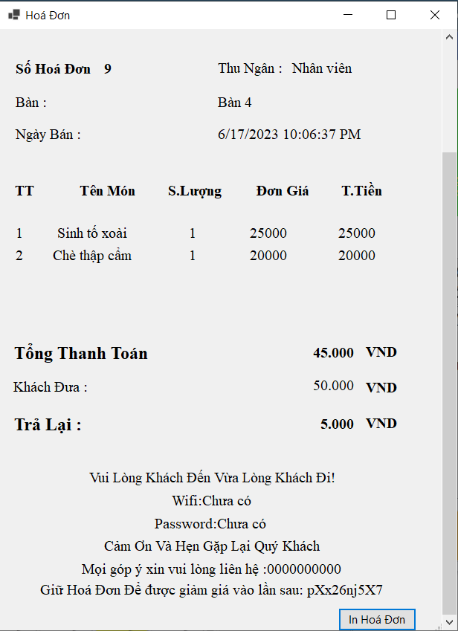

Figure 4.8: Invoice

### Manager Interface

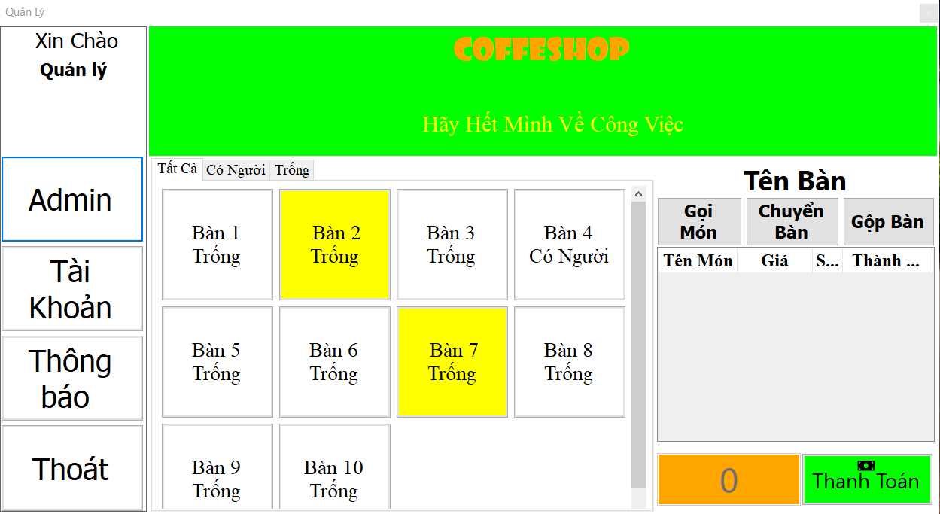

Figure 4.9: Manager Home page

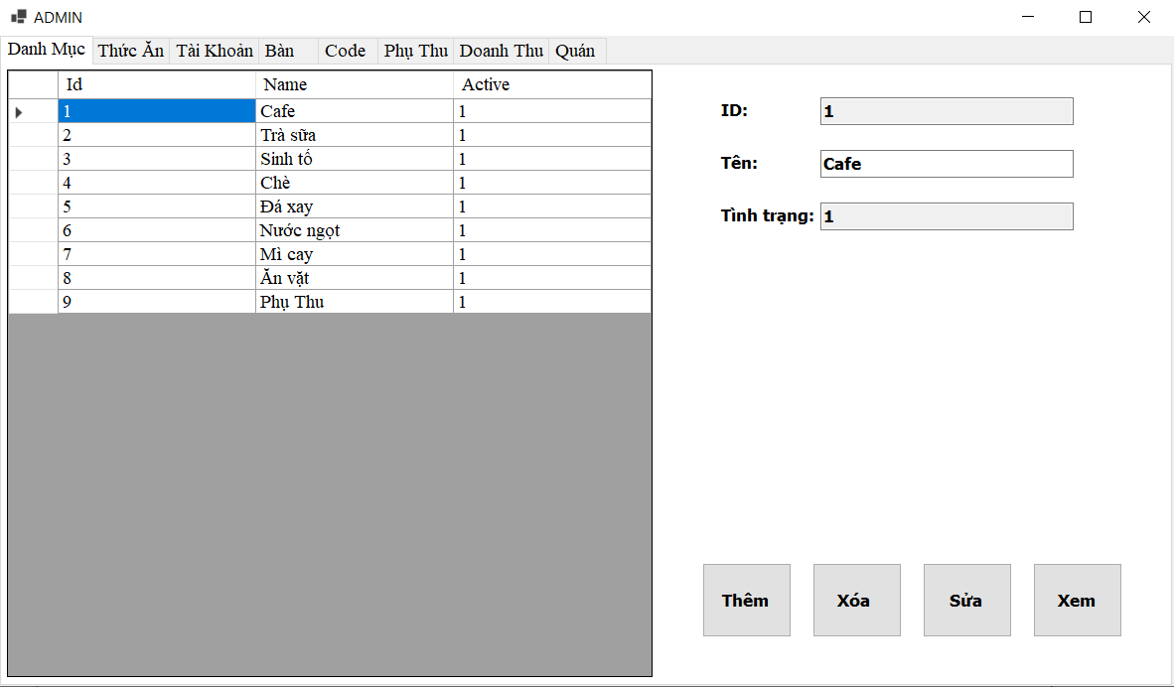

Figure 4.10: Manage Category Tab

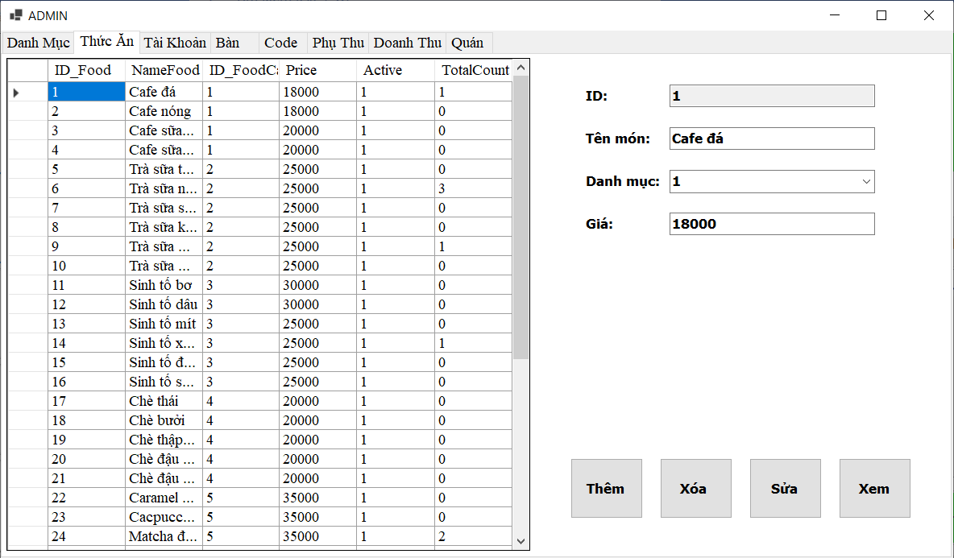

Figure 4.11: Manage Food Tab

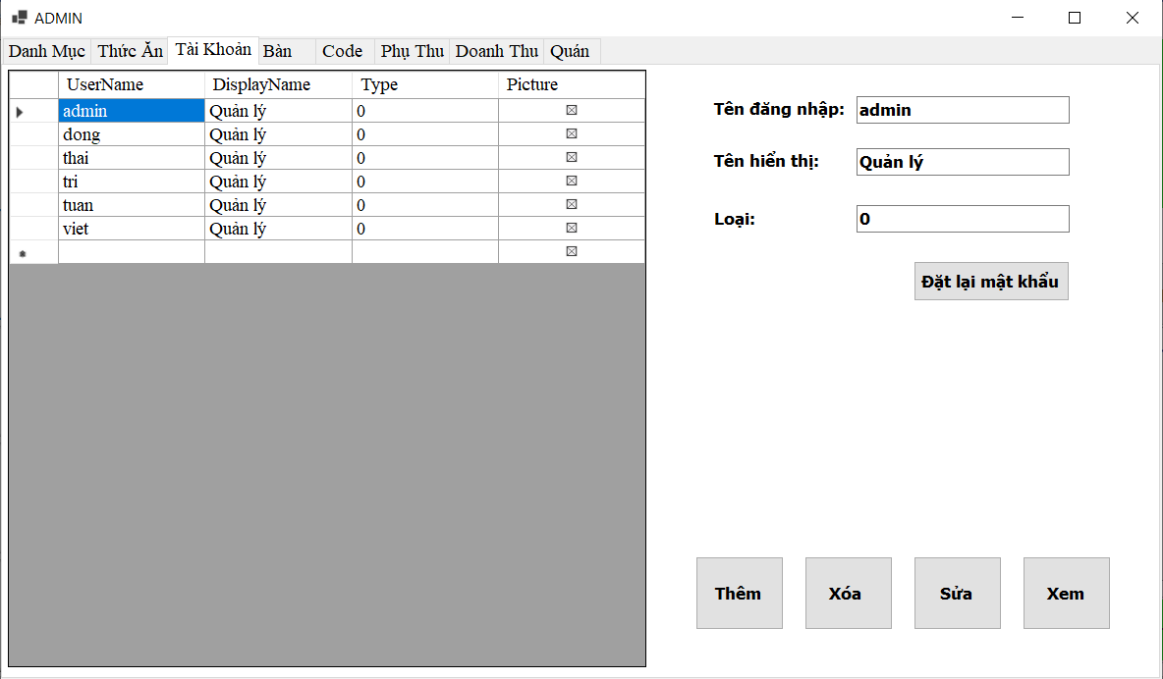

Figure 4.12: Manage Account Tab

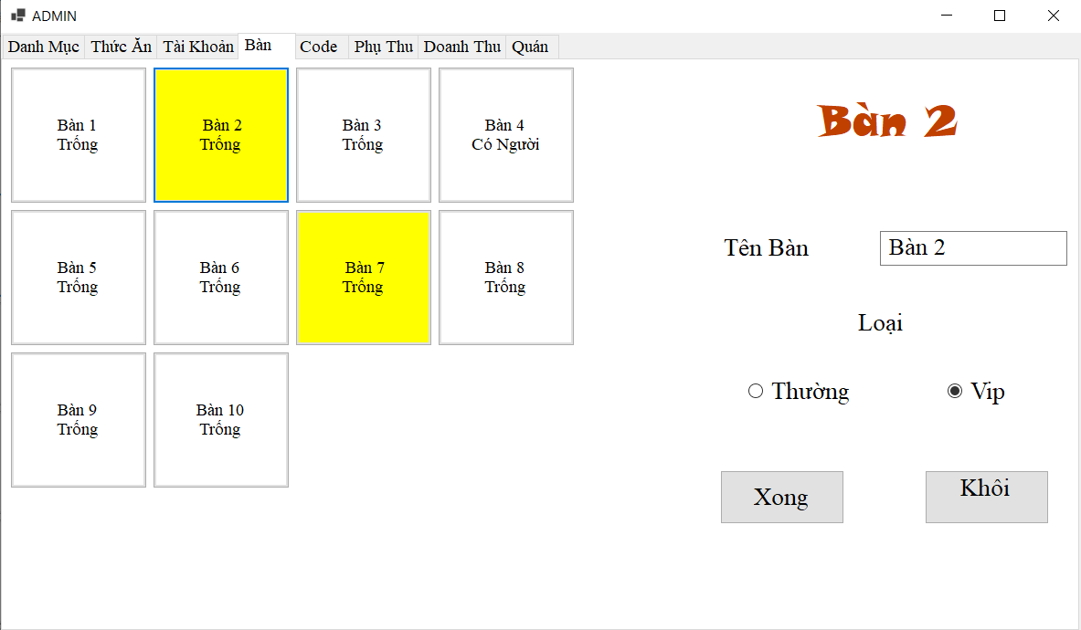

Figure 4.13: Manage Table Tab

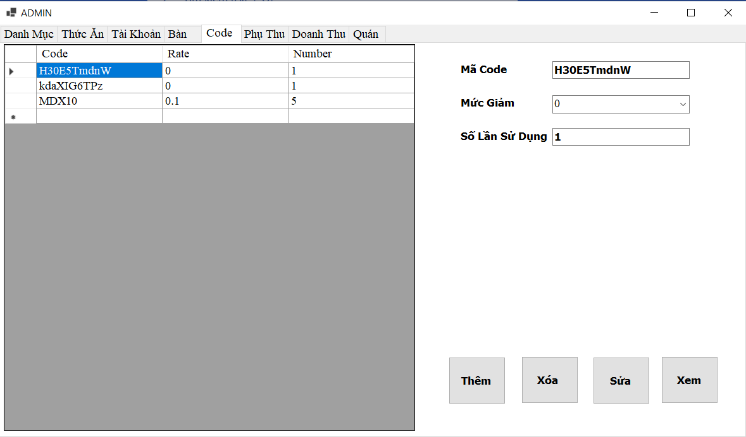

Figure 4.14: Manage Discount Code Tab

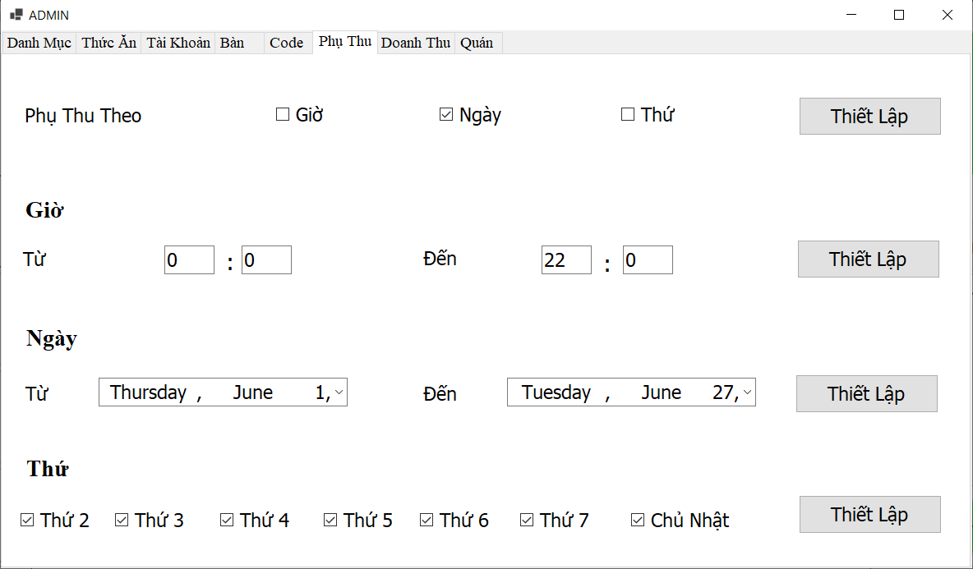

Figure 4.15: Manage Surcharge Tab

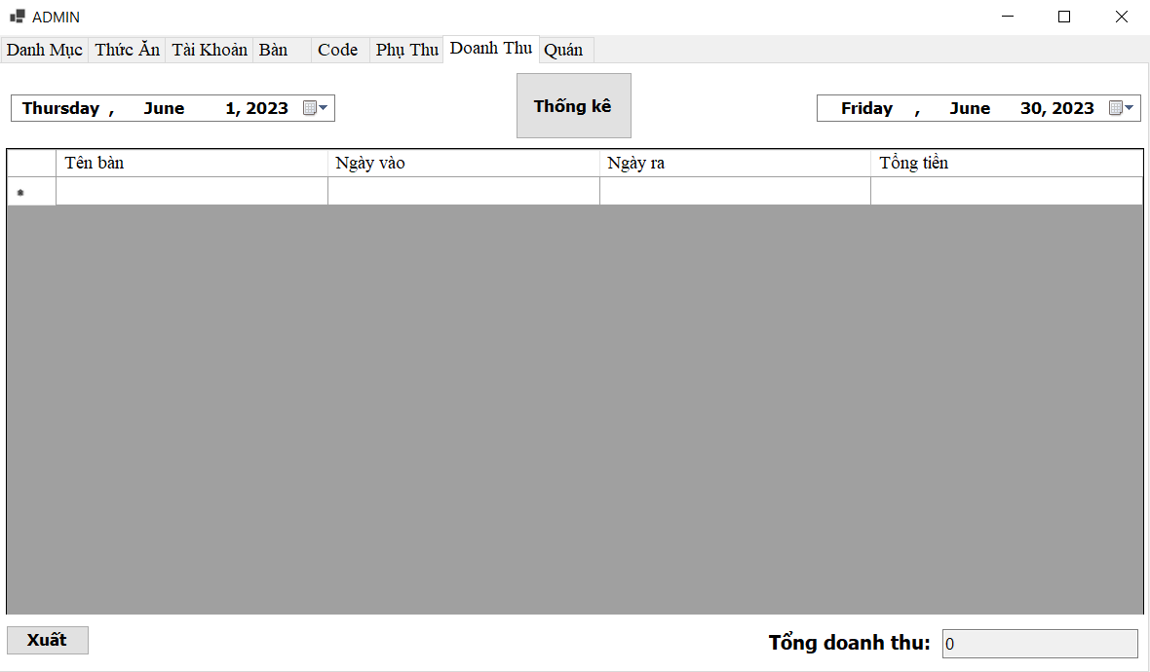

Figure 4.16: Statistic Tab

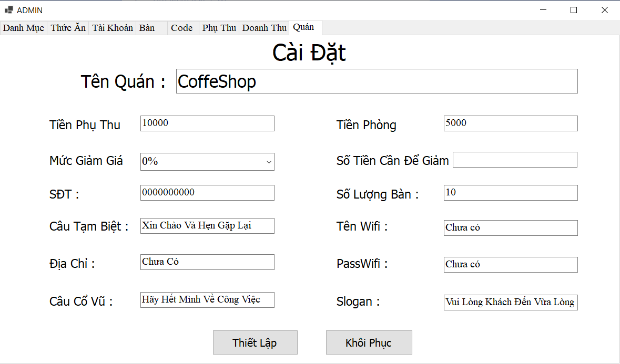

Figure 4.17: Manage Shop Information Tab

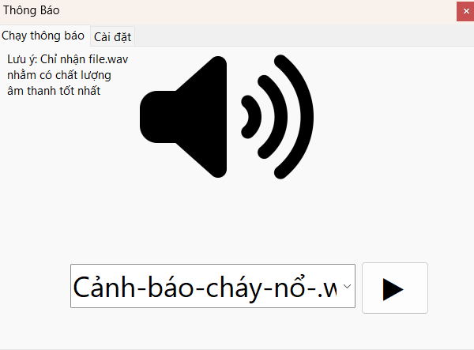

Figure 4.18: Run Notification Sound

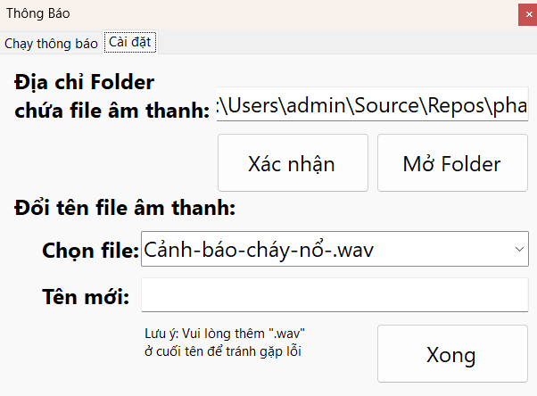

Figure 4.19: Manage Notification Sound Locations

CONCLUSION

## Project achievement

The Coffee Shop Management program helps the computerization in the store as well as the import and export of goods to be better, more accurate and scientific, increasing productivity and work efficiency. The coffee shop management system is relatively well completed, meeting the needs of updating and querying information quickly and solving the consistent organization of the database in information storage. We have authorized. One for employees and the other for system administrators, controllers and operators. These other tasks take a lot of our time, but it's worth it for us. Here are the main functions of our finished system:

* Manage food orders.
* Manage switch or merge tables.
* Manage information of foods, drinks, and tables.
* Manage order detail and payment.
* Account management.
* Output sheet for reports.
* Information is stored in a database, making it easy to retrieve, backup and restore easily, synchronous, fast, and reliable.

## Limitations

Due to the limited research time, the study of the issues is still incomplete. Practical knowledge and programming knowledge are still limited, so the professionalism of the program is not high, catching errors is not thorough in some places and some features are not optimized:

* There is no cancellation function.
* Statistical function has not been shown by graph.
* The function of adding food has not been optimized.

## Development direction

In the future, the team will develop and complete the project, specifically as follows:

* Continue to study and improve knowledge, especially databases and programming techniques to solve the above shortcomings.
* Need to add more specific and clear system checking functions.
* Extend some important functions so that system users can do their work easily.
* It is possible to combine using the system on mobile or website platforms to make it easier for users than the current software on computers.
* Design the program and edit the interface more eye-catching.
* Learn the security measures for the management application, and then apply it to the program.

# SELF ASSESSMENT

|  |  |  |
| --- | --- | --- |
| **Name** | Phạm Quang Việt | |
| **Role** | Leader | |
| **Contribution** | Report | **Chapter 3:**   * **Handle issues raising** * **Design UI** * **Develop applicationPlan & manage tasks** * **Monior progress** * **Class diagram Specification** (all SQL Table and Controller)   **Develop applicationPlan & manage tasks**  **Maintain & Upgrade App** (Add alert box, fix logic Checkout Form, Fix Notification Feature Maintain & Upgrade App (Add alert box, fix logic Checkout Form, Fix Notification Feature) |
|  | Demo Project | * **Building Database** * **Connect to Database** * **Query Database** |
| **Grade** | **9.5/10** | |

|  |  |  |
| --- | --- | --- |
| **Name** | Nguyễn Minh Thái | |
| **Role** | Member | |
| **Contribution** | Report | **Chapter 3:**   * **Manage discount codes** (Use case specification, Sequence, Activity Diagram, Class Diagram) * **Manage menu** (Use case specification, Sequence, Activity Diagram, Class Diagram) * **Revenue statistics** (Use case specification, Sequence, Activity Diagram, Class Diagram) * **Manage shop information** (Use case specification, Sequence, Activity Diagram, Class Diagram) * **Employee overview class diagram** * **Manager overview class diagram** * **Entity class diagram** * **Table** (State diagram) * **Discount code** (State diagram)   **Chapter 4: Implementation and Testing**  **Chapter 5: Conclusion** |
|  | Demo Project | **Manage Discount Code** **Manage food** **Manage Revenue statistics** **Manage Shop information** |
| **Grade** | **10/10** | |

|  |  |  |
| --- | --- | --- |
| **Name** | Phùng Trần Đăng Khôi | |
| **Role** | Member | |
| **Contribution** | Report | **Chapter 3:**   * **Manage account:** Use case specification, Sequence, Activity, class diagram. * **Manage category:** Use case specification, Sequence, Activity, class diagram. * **Manage surcharge:** Use case specification, Sequence, Activity, class diagram. * **Manage table:** Use case specification, Sequence, Activity, class diagram. * Mapping to Relational Model diagram from Entity class diagram |
|  | Demo Project | **Manage Account** **Manage Surcharge** **Manage categories** **Manage Desk** |
| **Grade** | **10/10** | |

|  |  |  |
| --- | --- | --- |
| **Name** | Từ Thị Huệ | |
| **Role** | Member | |
| **Contribution** | Report | **Chapter 1: Introduction**  **Chapter 2: Requirement Specification**  **Chapter 3:**   * **Use-case** * **Log in** (Use case, Sequence, Activity Diagram, Class diagram) * **Manage order** (Use case, Sequence, Activity Diagram, Class diagram) * **Manage payment** (Use case, Sequence, Activity Diagram, Class diagram) * **Arrange table** (Use case, Sequence, Activity Diagram, Class diagram) * **Play the announcement speaker** (Use case, Sequence, Activity Diagram, Class diagram) * **Bill** (Stage diagram) |
|  | Demo Project | **Login** **Manage indivial account** **Manage Shop**  **Announcement Speaker** |
| **Grade** | **10/10** | |